**AWS – Solutions Architect:**

**Global Infrastructure:**

19 Regions and 57 availability zones.

**Region**:

Each region is located in different geographies and can be mainly sub divided into

* North America
* South America
* APAC
* EMEA

Each region has multiple availability zones (at least 2 or more).

**Availability zones** are collection of data centers located close to each other or a data center.

If a data center is located at a considerable distance, then it may belong to another availability zone.

**Edge Locations:** CloudFront (Amazon CDN) These are smaller locations which are used to cache content. Currently we have about 150 of these edge locations.

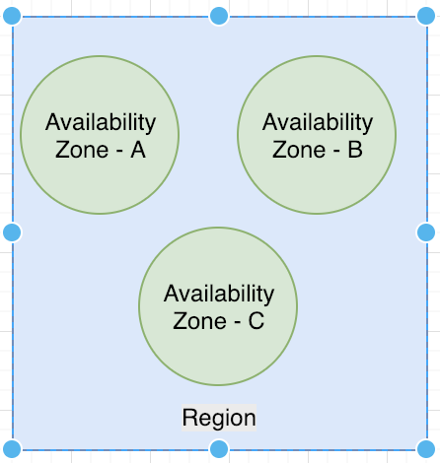

**Important Services:**

Security and compliance – (IAM)

Networking (Route 53 and VPC)

Compute (EC2 and lambda)

Database (RDS, Redshift and Dynamo DB)

Storage(S3)

**IAM (Identity and Access management):**

* IAM allows to manage users and their level of access in AWS console.
* Centralized access of AWS
* Shared access of AWS
* Granular permissions
* Identity federation (Active Directory/LinkedIn/Facebook) – allows to login through Facebook, active directory etc.
* Temporary access
* PCI DSS compliant
* Multifactor Authentication
* Password Rotation

IAM has four major parts:

* Users – end users who will login to AWS
* Groups – Group into which the users belong. All users in a group will inherit permissions assigned to that group.
* Policies – These are documents in JSON format which detail the permissions.
* Roles – These are used by AWS resources to access or perform operation on other AWS resources. E.g.: if a resource needs permission to write to S3, it will need write role for S3.

**IAM - Lab**

Security, Identity and Compliance > IAM

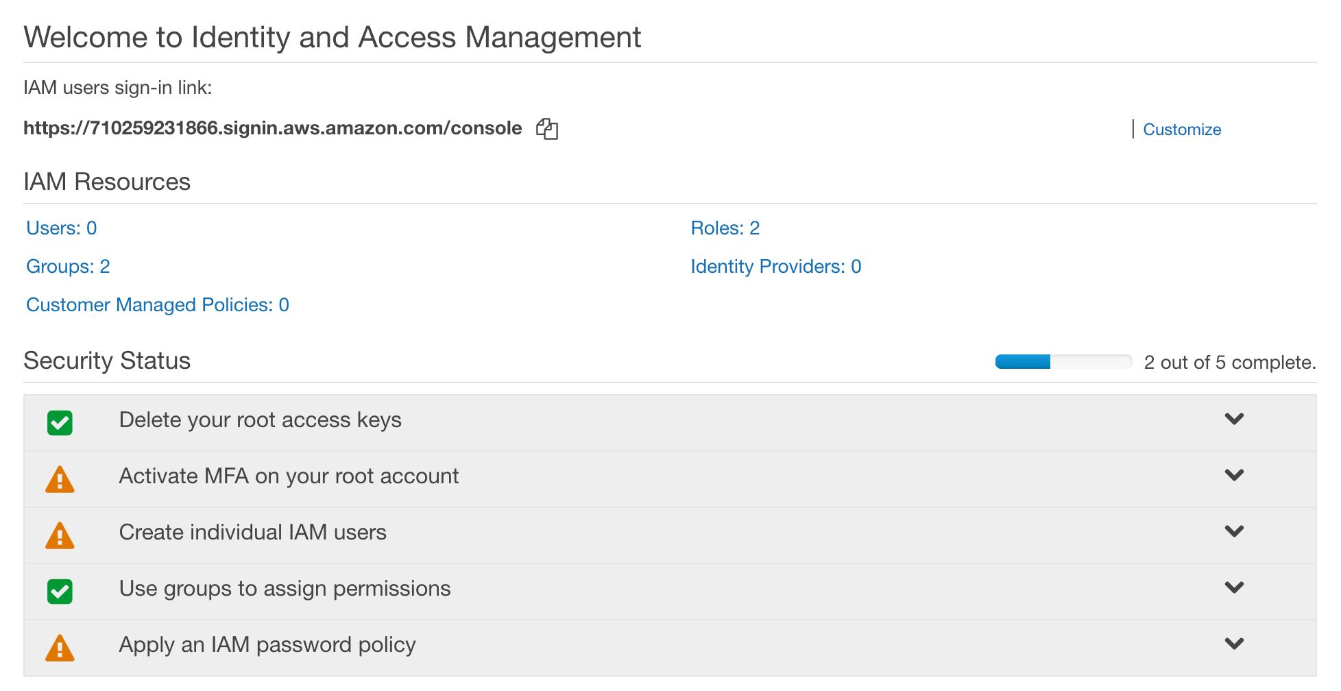

We can edit the IAM users sign in link by clicking customize.



This is a publicly accessible URL.

Root User: This is the user used to sign up to aws for the very first time. This is a god mode user having all access.

All resources in IAM are global at this time. They are not region specific.

1. **Activate MFA in your root account.**

This helps prevent unauthorized access in case username/password is stolen.

There are many ways to activate this.

We have used the virtual MFA device and scanned the QR code using google authenticator to generate random number.

1. **Create some users**

* Add a user.
* The user can be assigned programmatic or console access or both.
* The user needs to be added to a group for it to have access. A new user does not have any access by default. In this case a group Developers was created with AdministratorAccess job function policy assigned to the group and the user has been added to the group. A policy is usually described in JSON.
* Because programmatic access is assigned to the user, a secret id key pair is generated while creating the user. If this credential is lost, it will need to be regenerated. This secret id key pair can be downloaded as csv, copied from the page or sent as a mail. It can be deleted by going to security credentials under user.
* The secret id key pair cannot be used to login to console. Password needs to be used for console login.

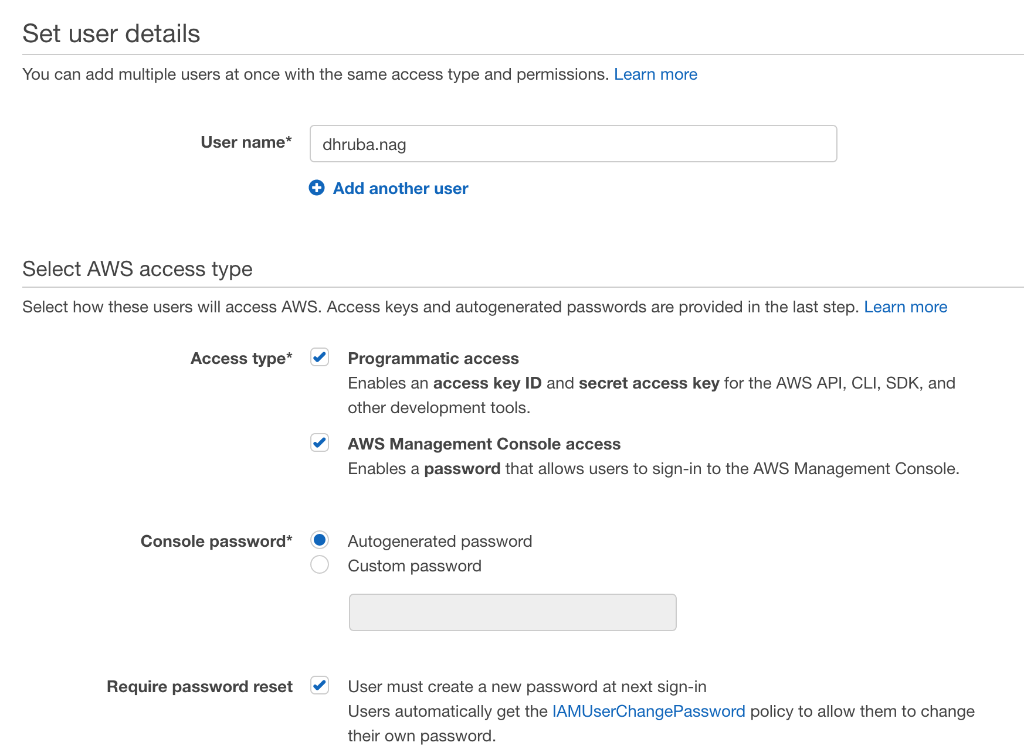

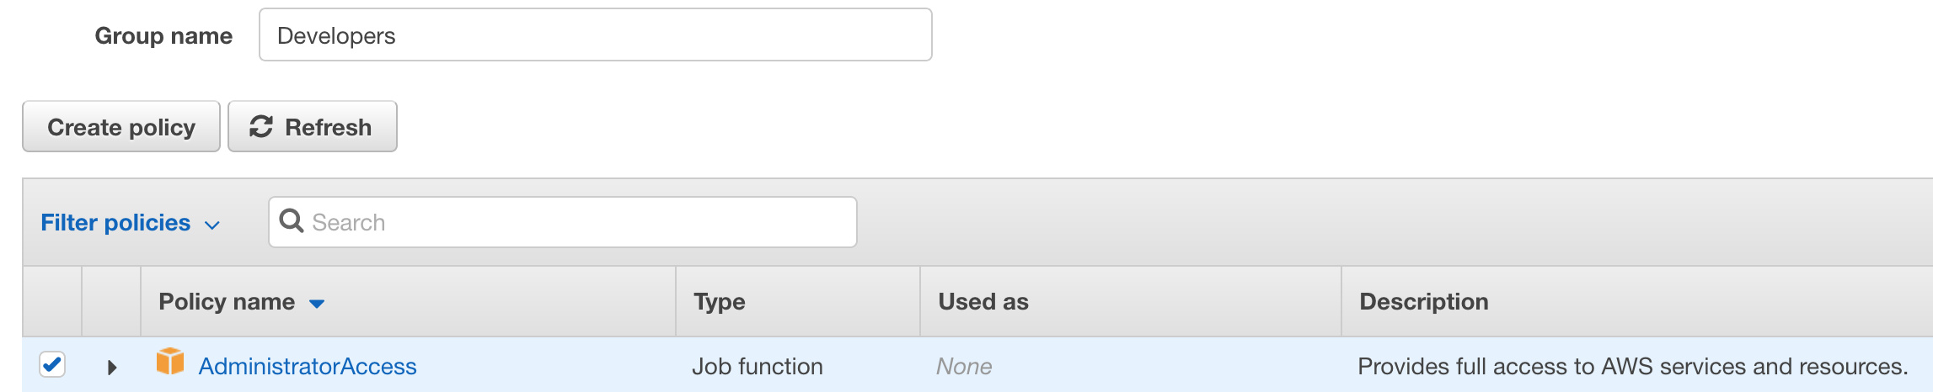

Secret id key pair:

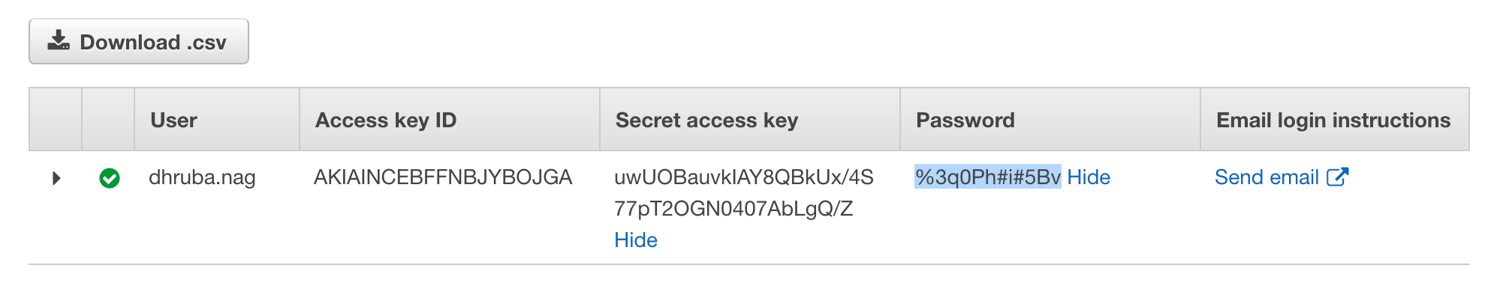

1. **Password policy**

Password policy can also be implemented in IAM

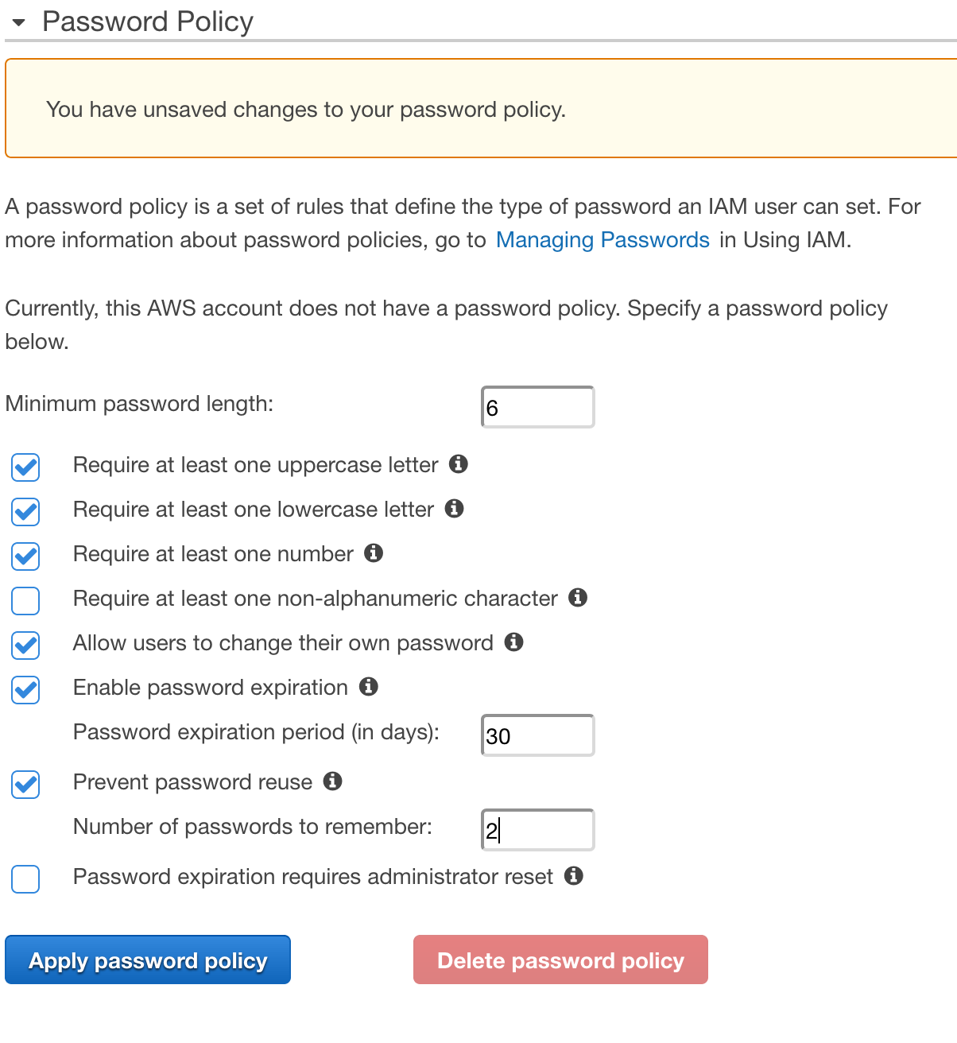

1. **Roles used by AWS resources**

Roles are used to manage access for aws resources.

The below role was created for ec2 instances to access s3.

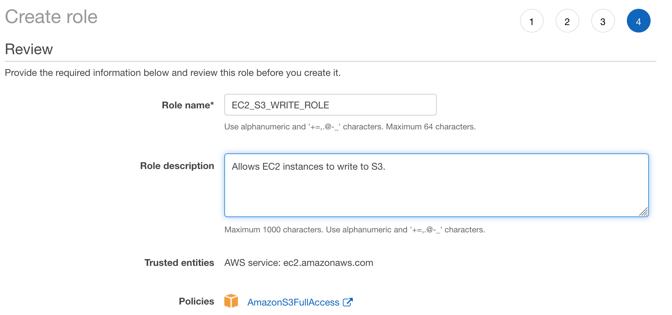

**Billing Alarms:**

There are many ways.

1. Click on account name>my account>Dashboard
2. Use Management and Governance > CloudWatch >Billing > Create Alarm

When AWS total charges for month > 10 USD, send notification to email.

A power user access allows access to all aws services except management of users and groups in IAM.

**Amazon object storage and CDN - S3, GLACIER and CLOUDFRONT**

**S3 – simple storage service**

* It provides it teams with secure, durable, highly-scalable object storage.
* It can be used to store and retrieve any amount of data from anywhere in the web.
* It is object-based storage (used to store documents and files).
* It is spread across multiple devices and facilities.
* Files can be anywhere between 0 to 5 TB.
* Unlimited storage (pay by the gig)
* Files are stored in buckets (folders in the cloud). There can be folders in buckets as well. Each bucket has a universal namespace. It will have a unique DNS address and hence the bucket name has to be unique globally.
* If upload of a file is successful, we are going to get a http 200 response code.

**Sample URL for a bucket:**



region.amazonaws.com/bucket name

**Data consistency model for S3:**

* Read after write consistency for puts of new objects. It means that immediately after a file is uploaded, it is available to read.
* Eventual consistency for overwrite PUTS and DELETES – When a file is updated, the contents may not be available immediately, we can get the old file or the new file. It takes some time to propagate. S3 is spread out across availability zones. So, when a file is updated, the update takes some time to replicate and propagate to all availability zones.

**S3 – simple key value store.**

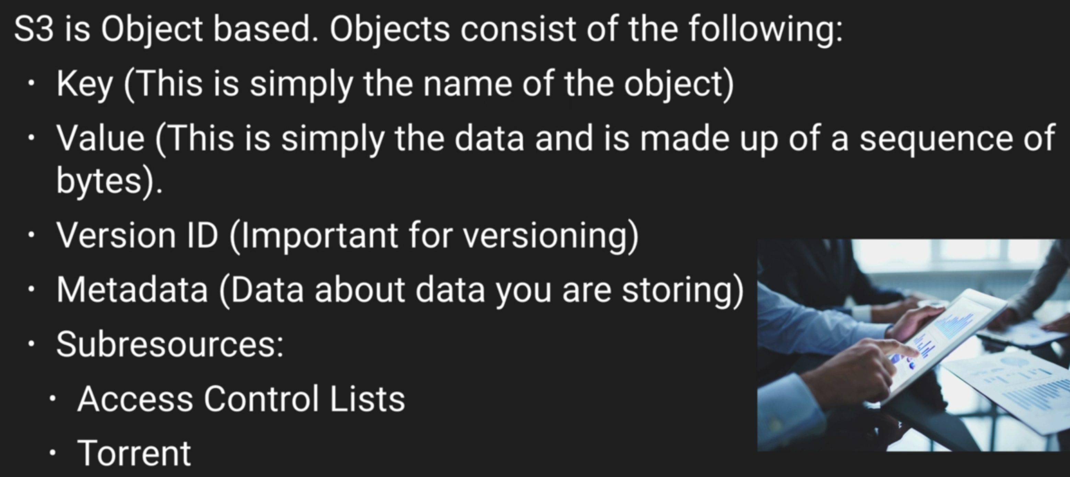

**S3 – basics:**

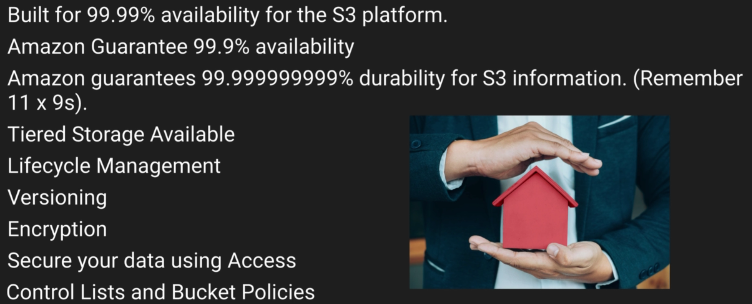

Access control lists allow application to securely access individual files.

Bucket policies apply to bucket level.

**S3 storage tiers/classes:**

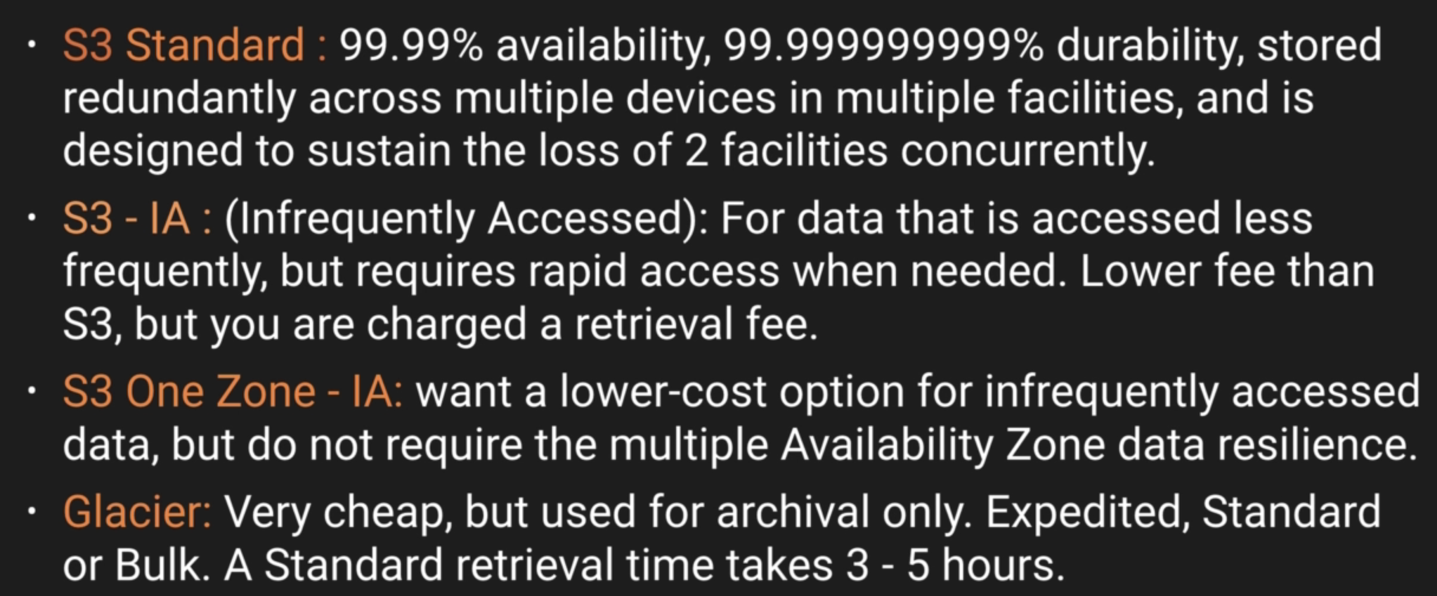

Here for s3 standard multiple device means multiple disks and multiple facilities mean multiple availably zones.

* Glacier: Expedited – minutes, Standard 3 – 5 hours, Bulk 5 – 12 hours
* Lowest cost, do not care about retrieval times – glacier, mainly used for archival.
* Care about retrieval times but keep it low cost – IA
* Do not care about costs and keep it durable – standard
* No retrieval fee for s3 standard.

S3 Storage Classes/Tiers:

* S3(durable, immediately available, frequently accessed)
* S3-IA (durable, immediately available, infrequently accessed)
* S3 One Zone – IA (even cheaper than IA, but only in one availability zone)
* Glacier (Archived data, where you can wait 3-5 hours before accessing)

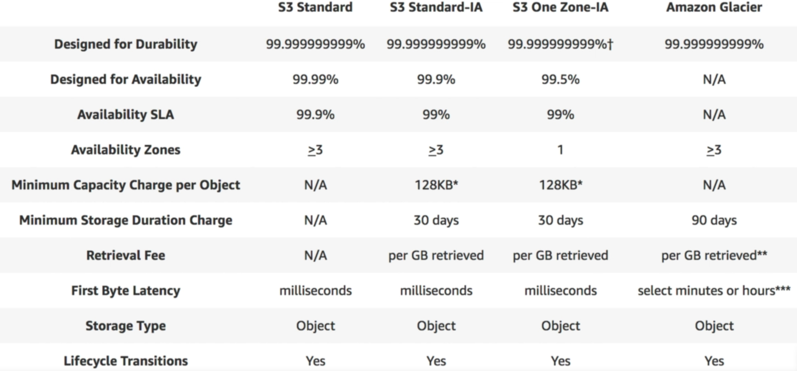

**S3 – Charges**

Charged for

* Storage
* Requests
* Storage Management pricing – This means cost for metadata/tags. A particular bucket may be tagged to a department. There is a cost for this tag.
* Data transfer pricing – When a data is replicated across regions, there is a cost to transfer data from one region to another. This is called data transfer pricing.
* Transfer Acceleration – When a user uploads large data to S3, they can accelerate the transfer using amazon CDN. There are many more CDN edge locations than availability zones. So, the user uploads data to a CDN edge location instead of a S3 availability zone. This CDN edge location has high speed optimized connections to the Amazon s3 location and can transfer quickly.

Please read S3 FAQ.

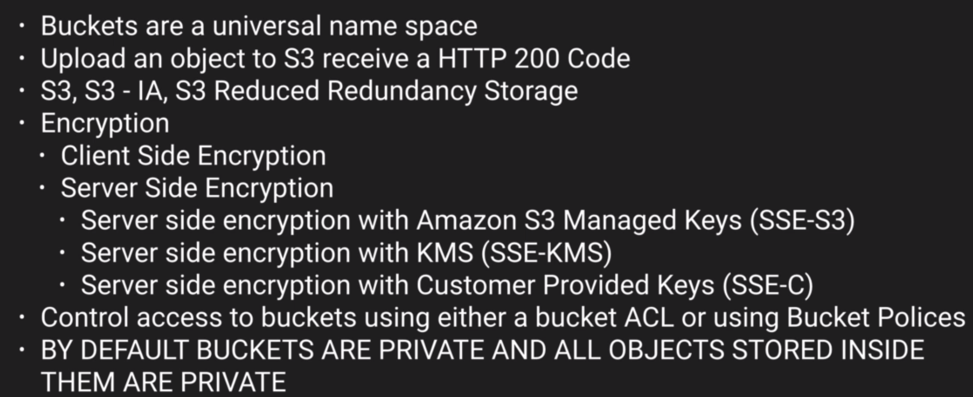

S3 does not let us select region but when creating a bucket, you can select region.

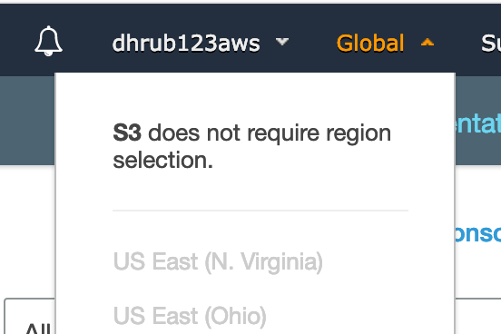

All buckets and objects inside buckets are private by default.

To make an object publicly accessible, we need to change bucket policy to allow public access and then make the object public as well.

**Create a new Bucket:**

1. Name and region

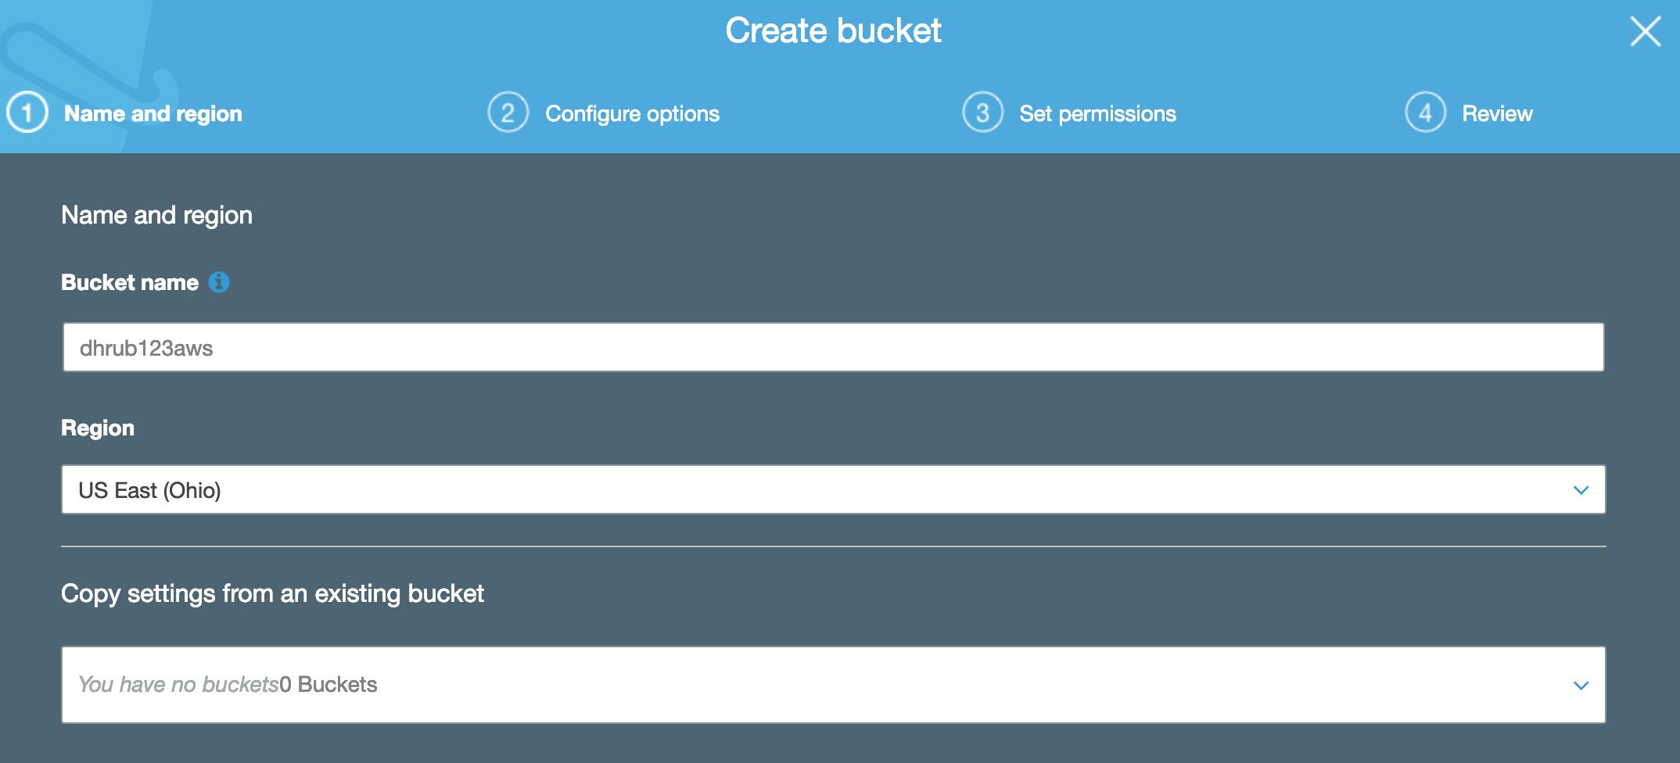

1. Properties

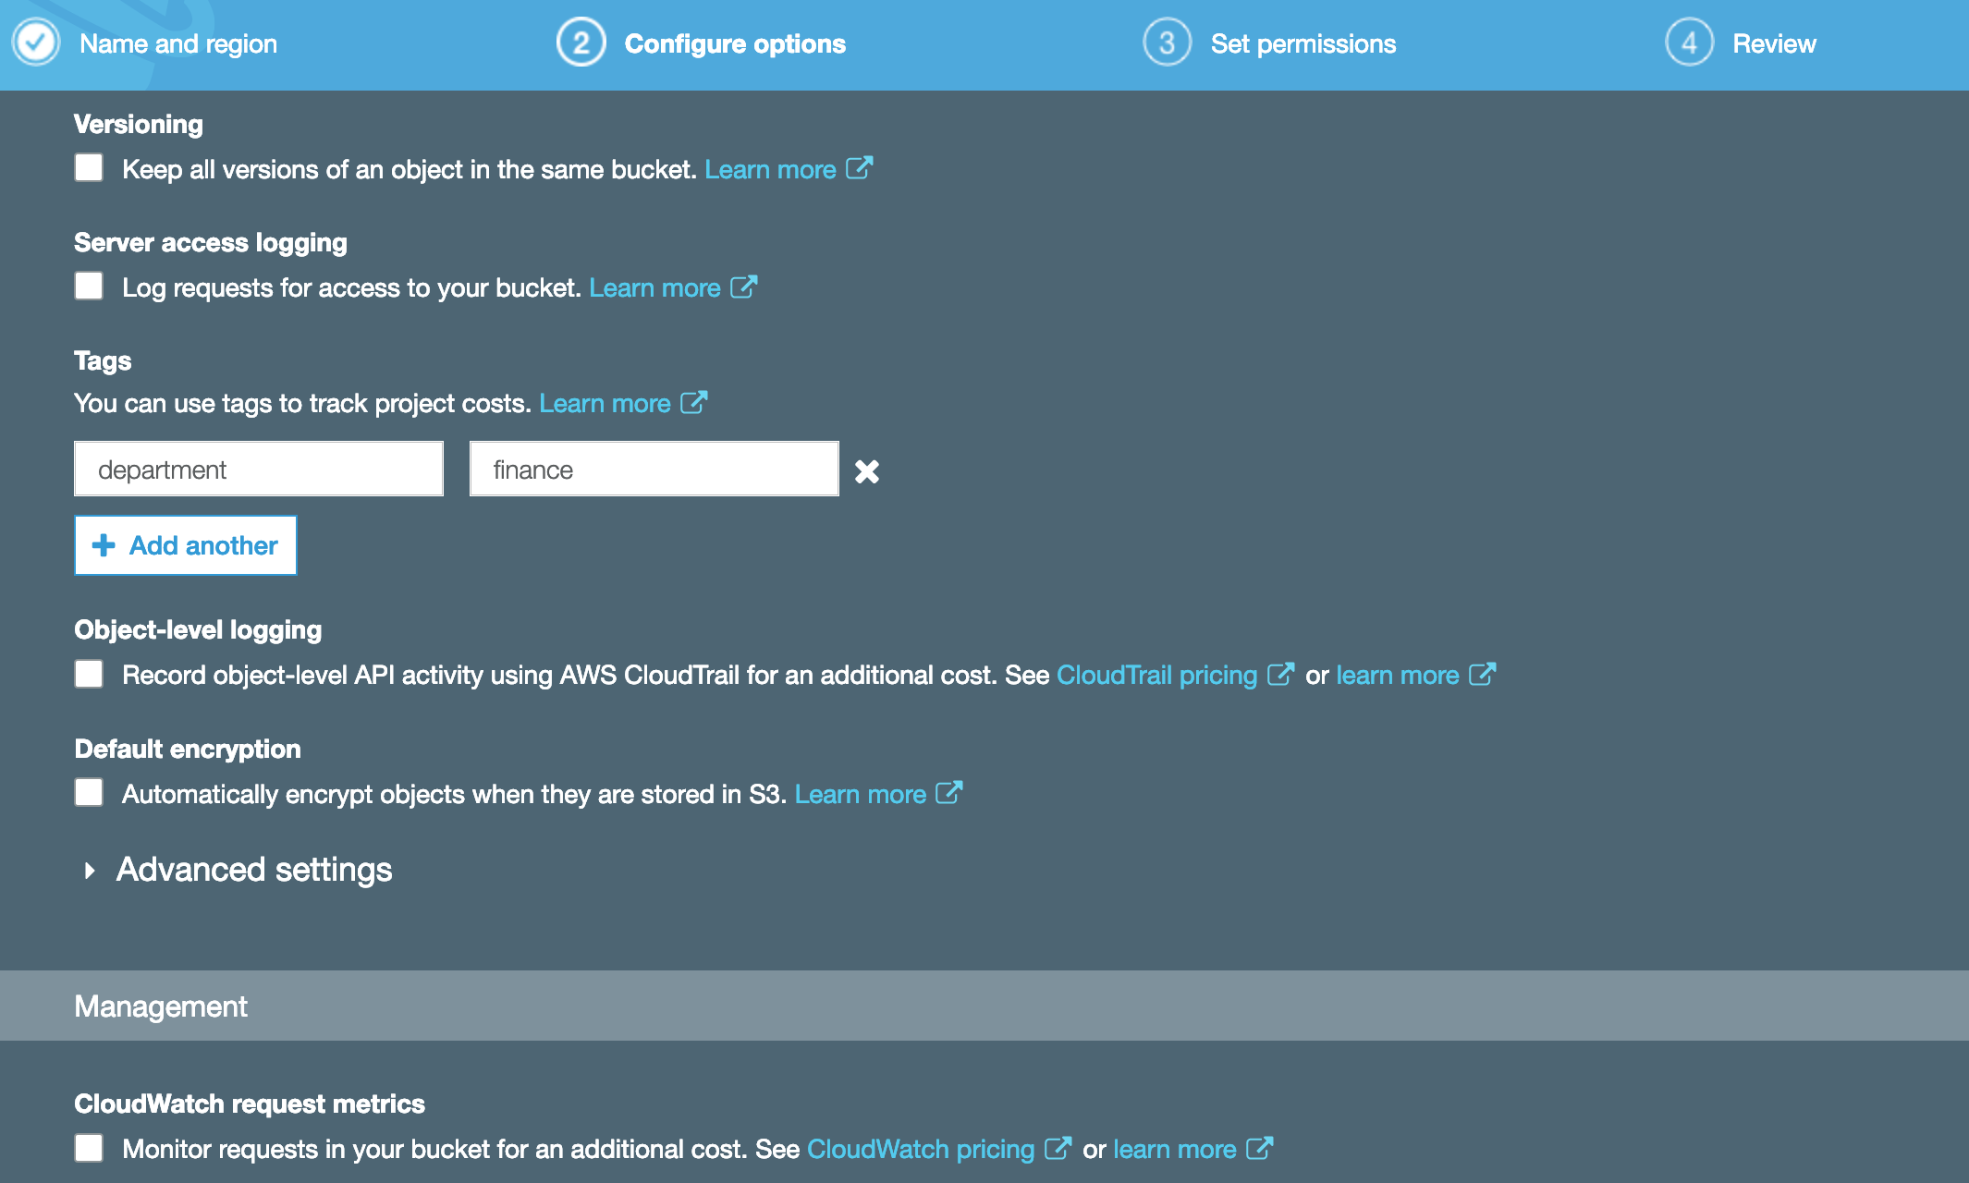

1. Permissions

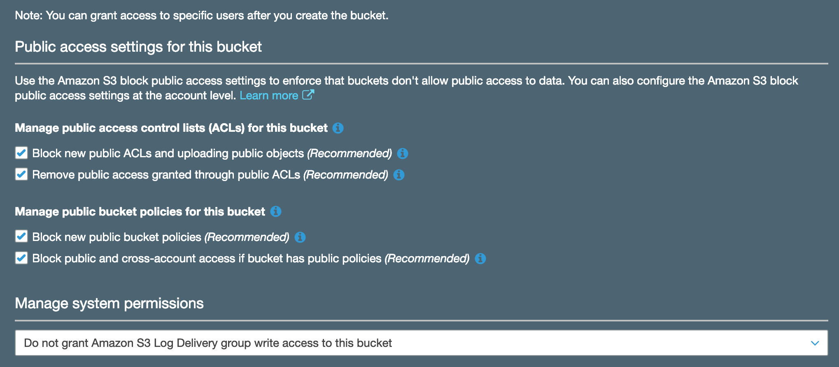



Upload files:

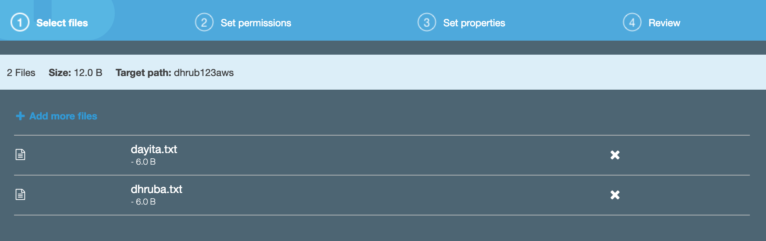

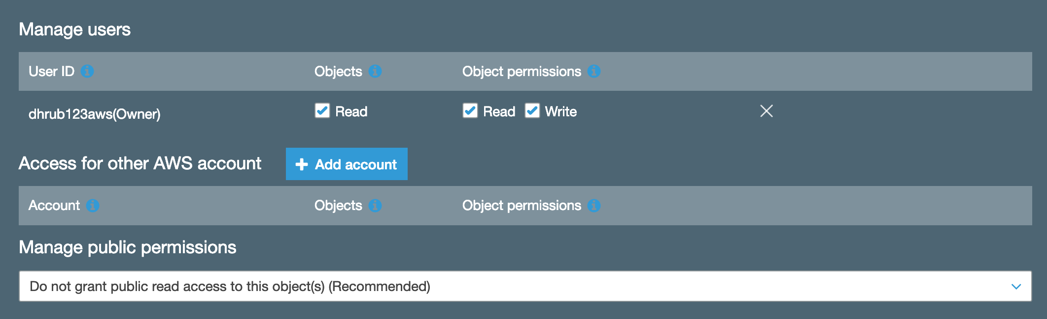

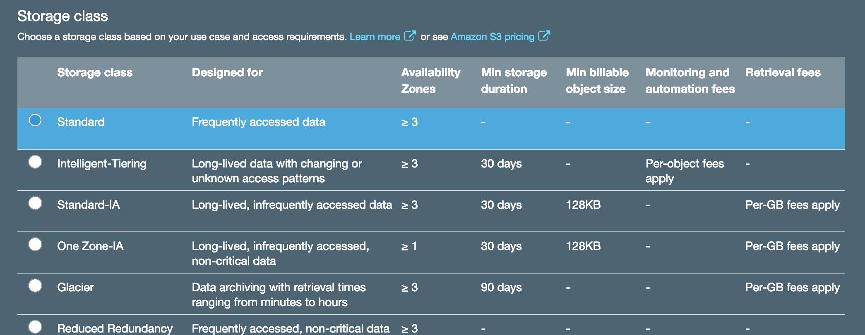

But these files are all private.

To make them public, we have to do 2 steps.

1. Enable public access settings for the bucket.

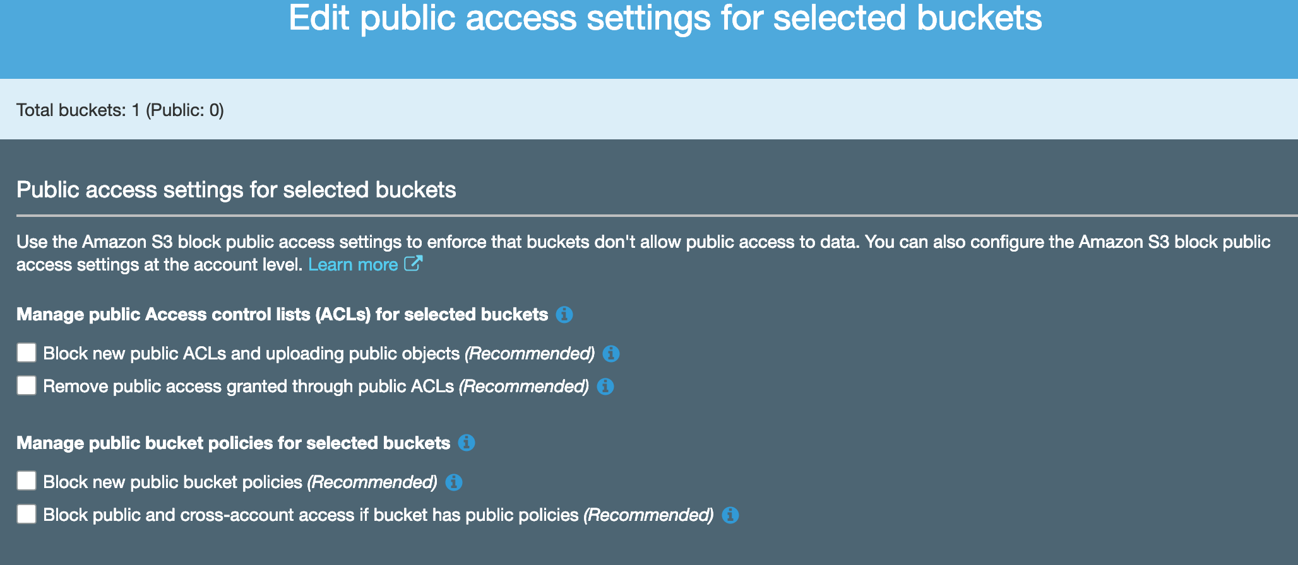

1. Make the object public.

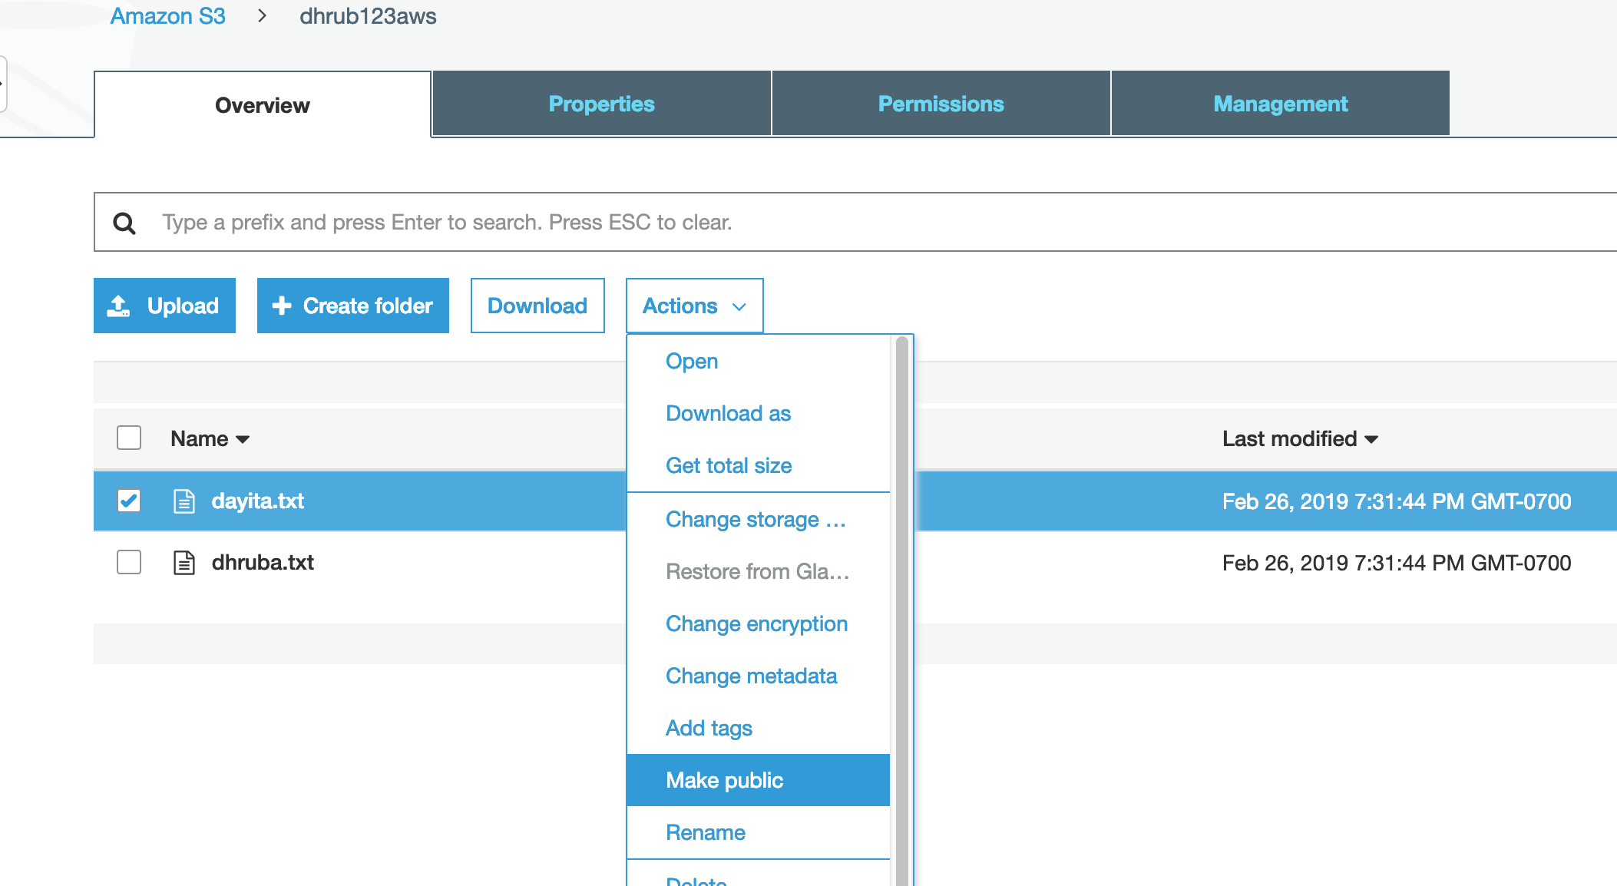

**Versioning:**

<https://docs.aws.amazon.com/AmazonS3/latest/dev/ObjectVersioning.html>

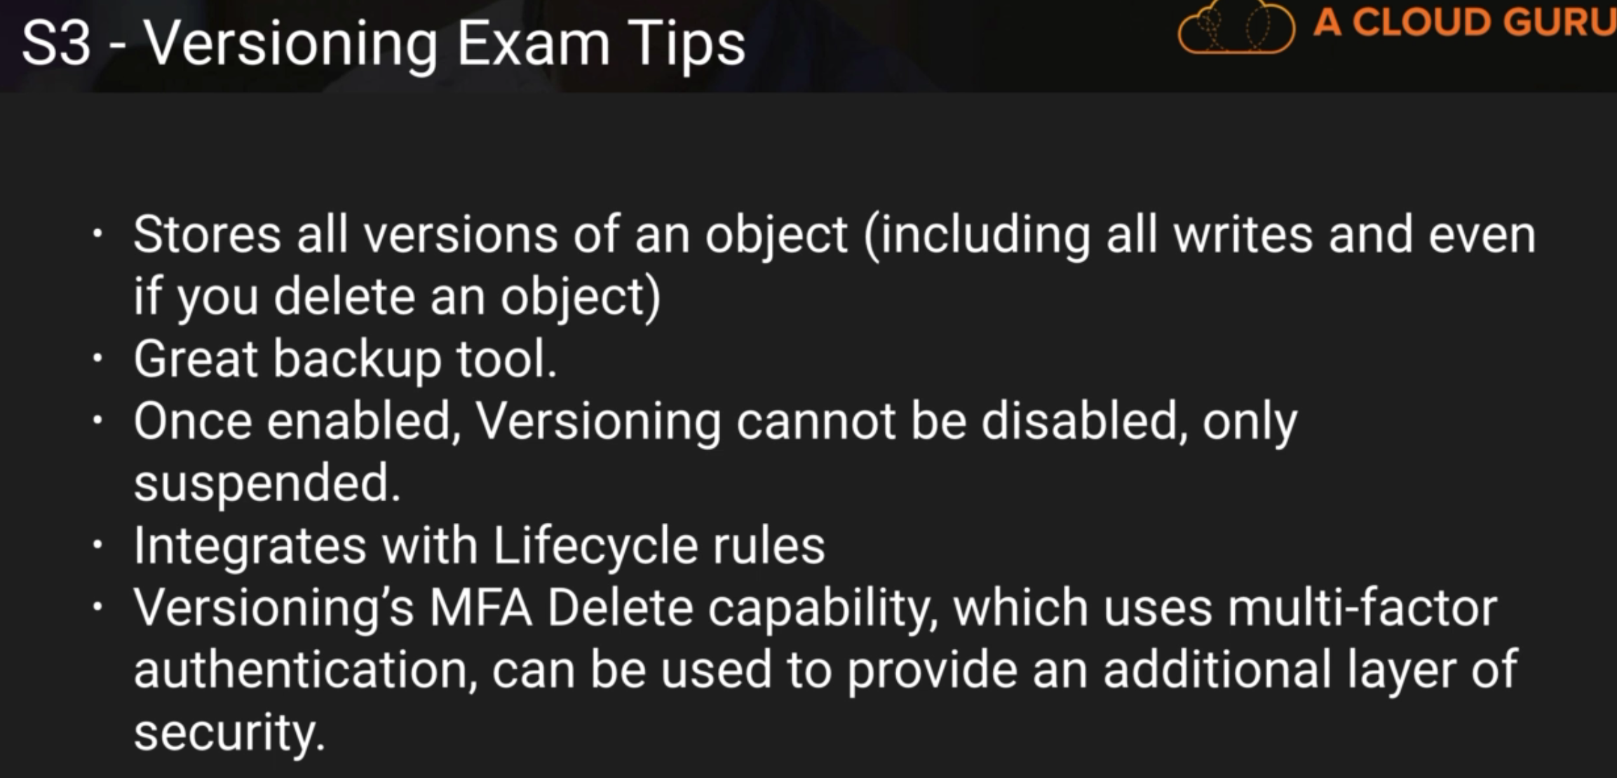

For each new version, we have to make the new version of object public to allow public access.

In a versioned bucket, when delete action is executed, a new delete marker is created. Deleting that delete marker will restore the object. To permanently delete the object, we will need to delete all versions of the object including the delete marker.

Enable Versioning:

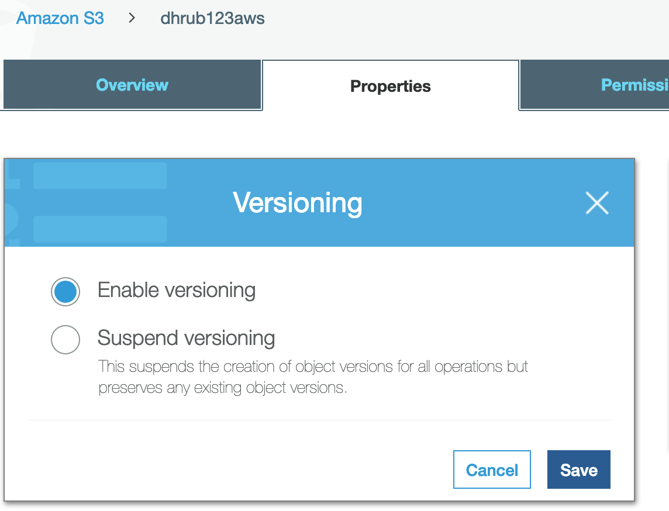

When a new version of a file is uploaded, we can see the version ids.

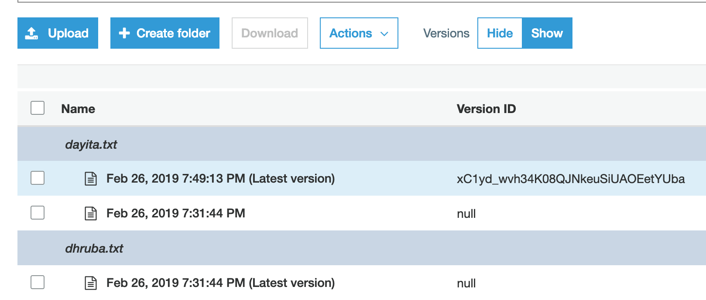

Deleting an object creates a delete marker. If the delete marker is deleted, the object will be restored.

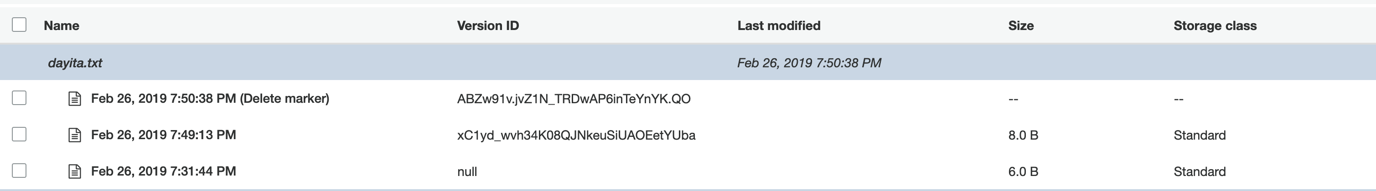

To permanently delete a file, all versions along with the delete marker needs to be deleted.

**Cross Region Replication:**

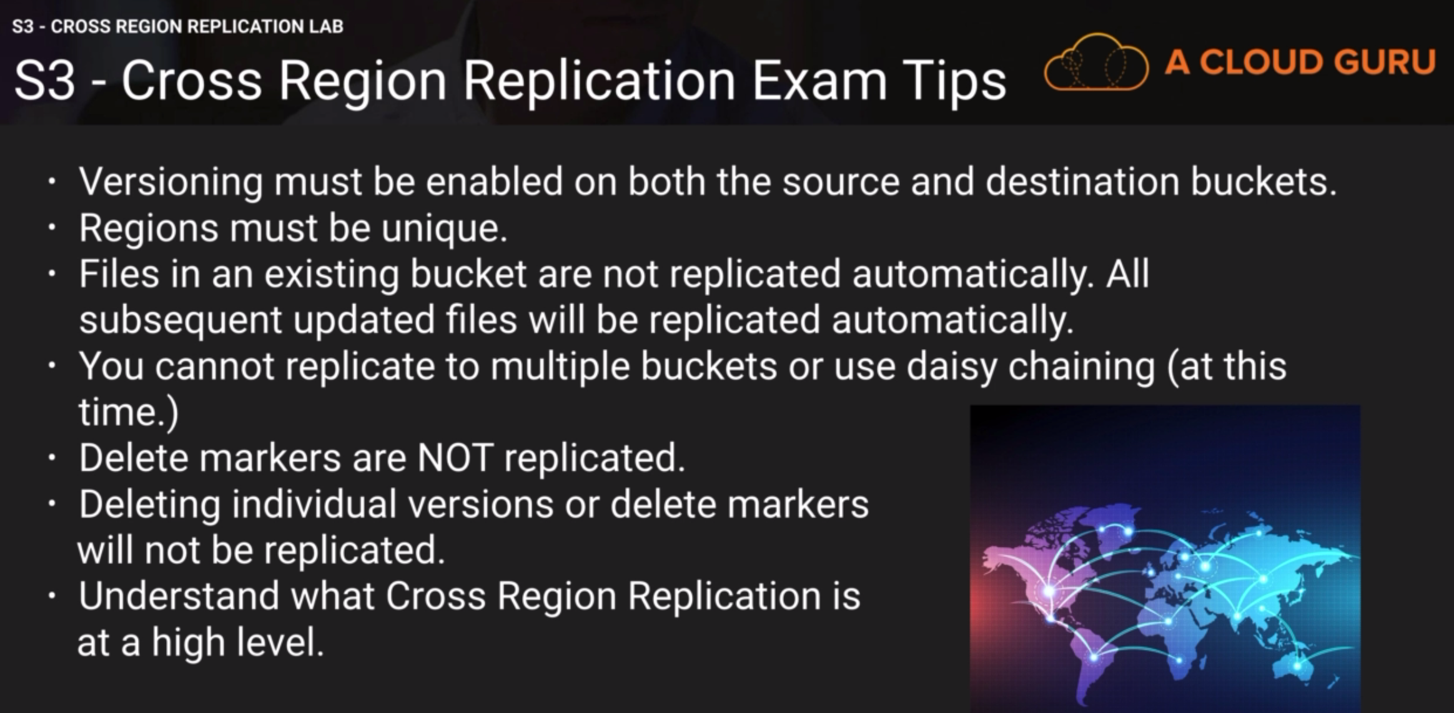

<https://aws.amazon.com/solutions/cross-region-replication-monitor/>

Existing files are not moved. To do that CLI is needed.

We have 2 buckets.



We enable replication on source bucket.

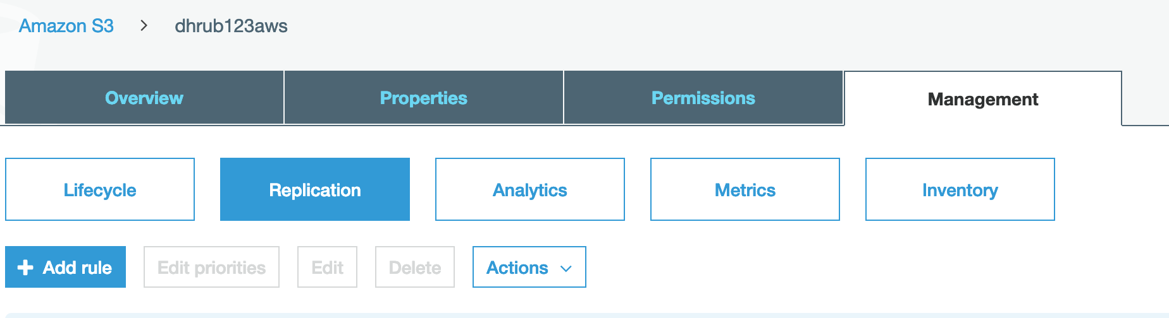

We can select storage class for the target and we have to create or select an existing role.

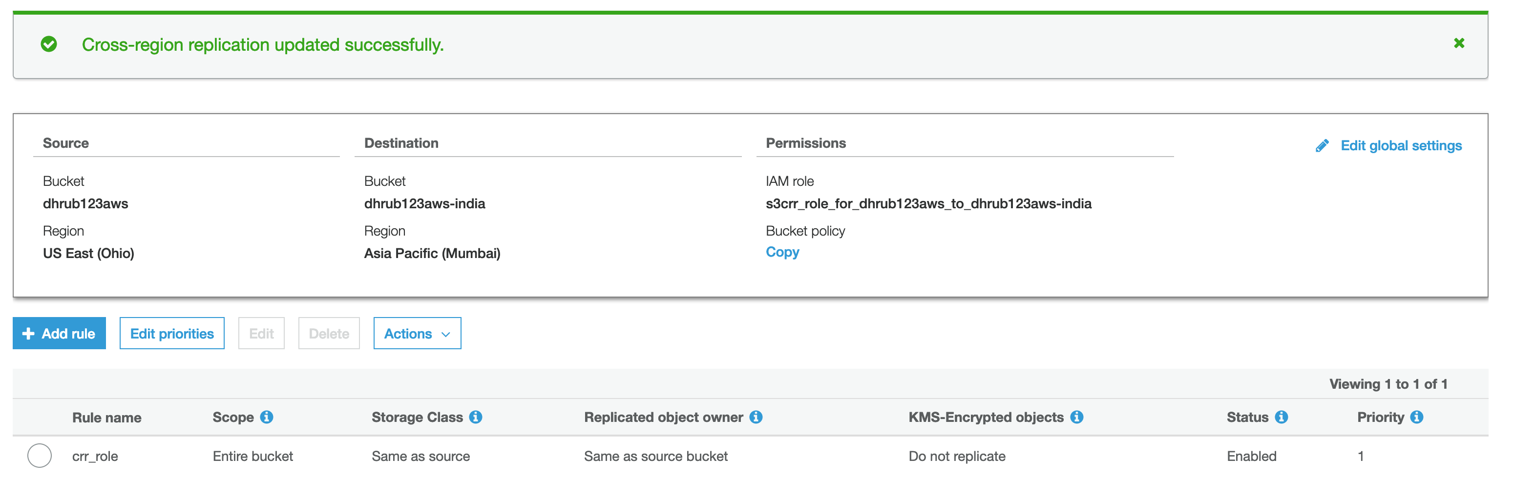

Uploading an object will put that object in the backup bucket.

US Bucket:

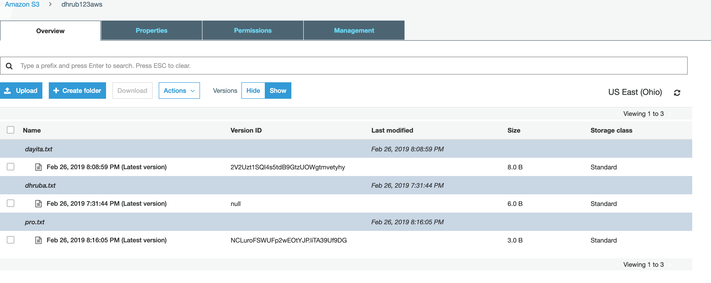

India Bucket:

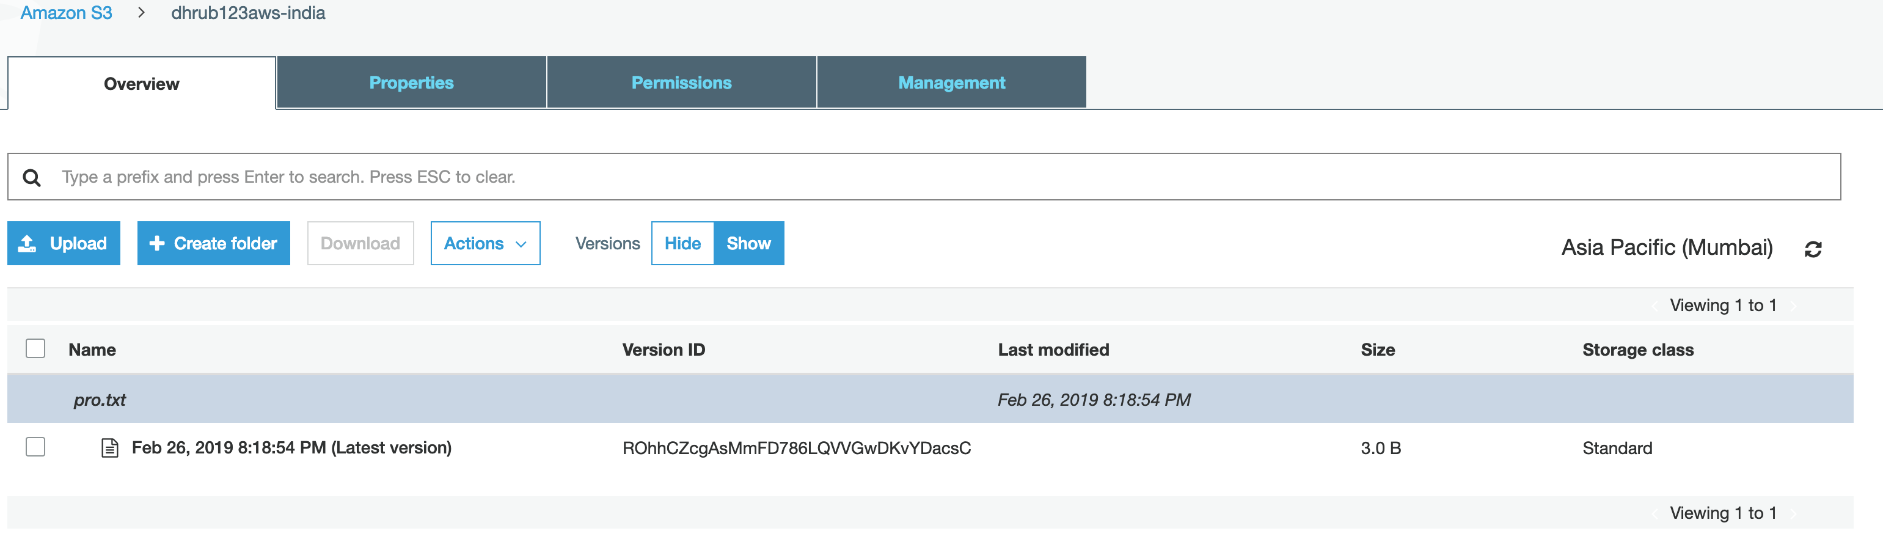

Deletion is not reflected in the backup bucket but version update is reflected.

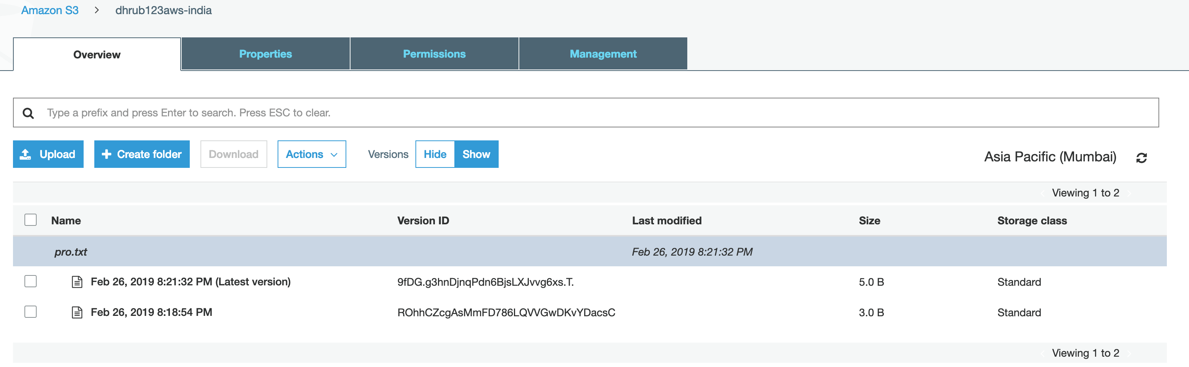

Using AWS CLI to move existing files:

Create a group with admin access and assign a user (which has programmatic access) to the group. Get the access key id and secret access key and use that to login using cli.

To install CLI, go to downloaded folder and run command

sudo ./awscli-bundle/install -i /usr/local/aws -b /usr/local/bin/aws

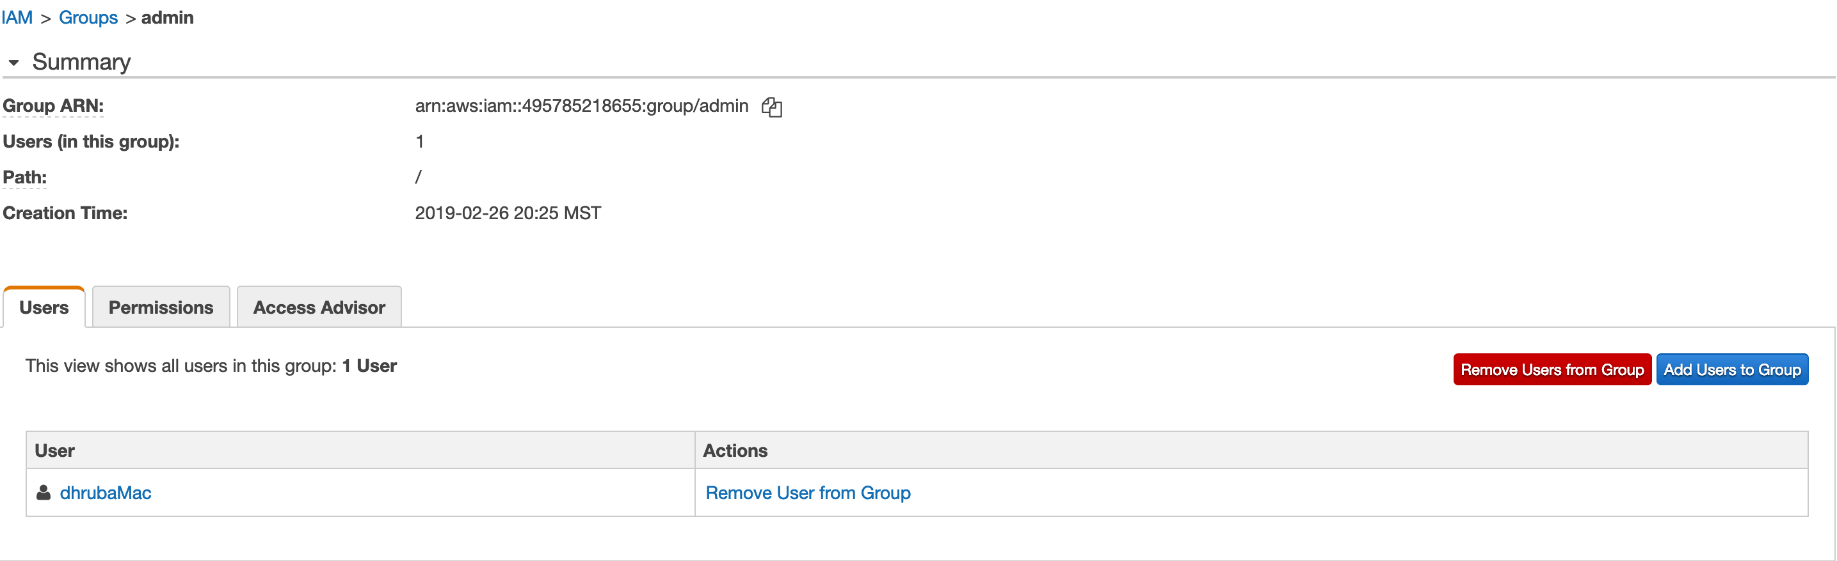



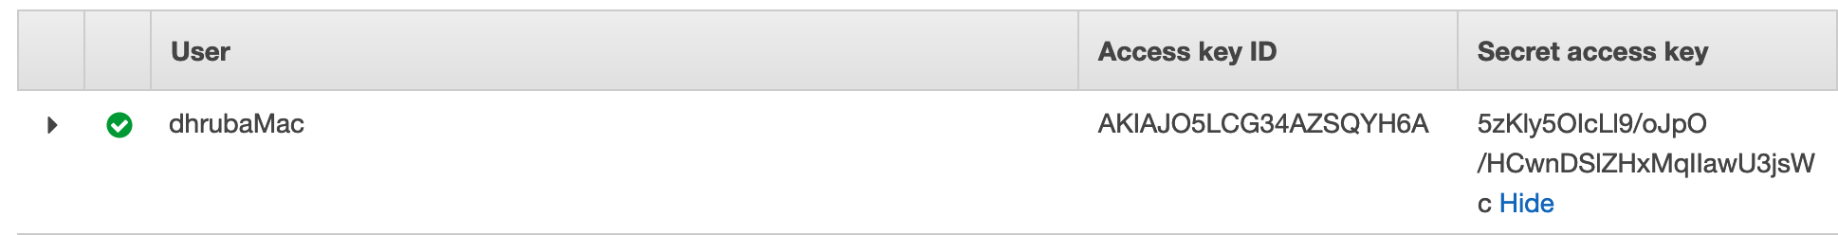

Copy files from source to destination using following commands.

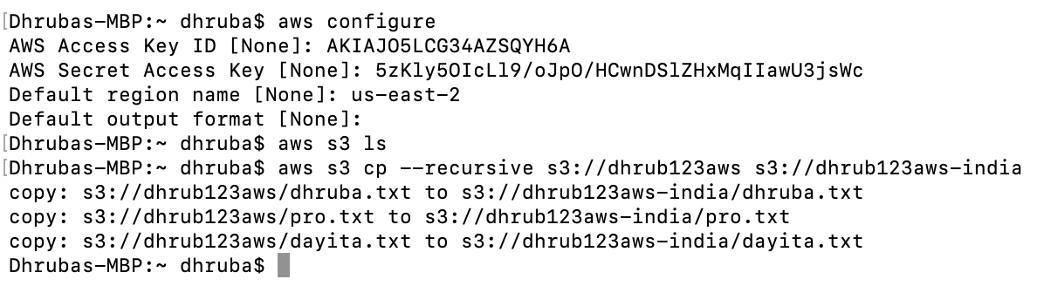

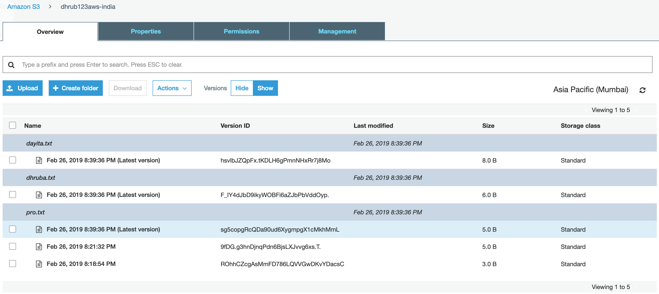

**Lifecycle Management in S3:**

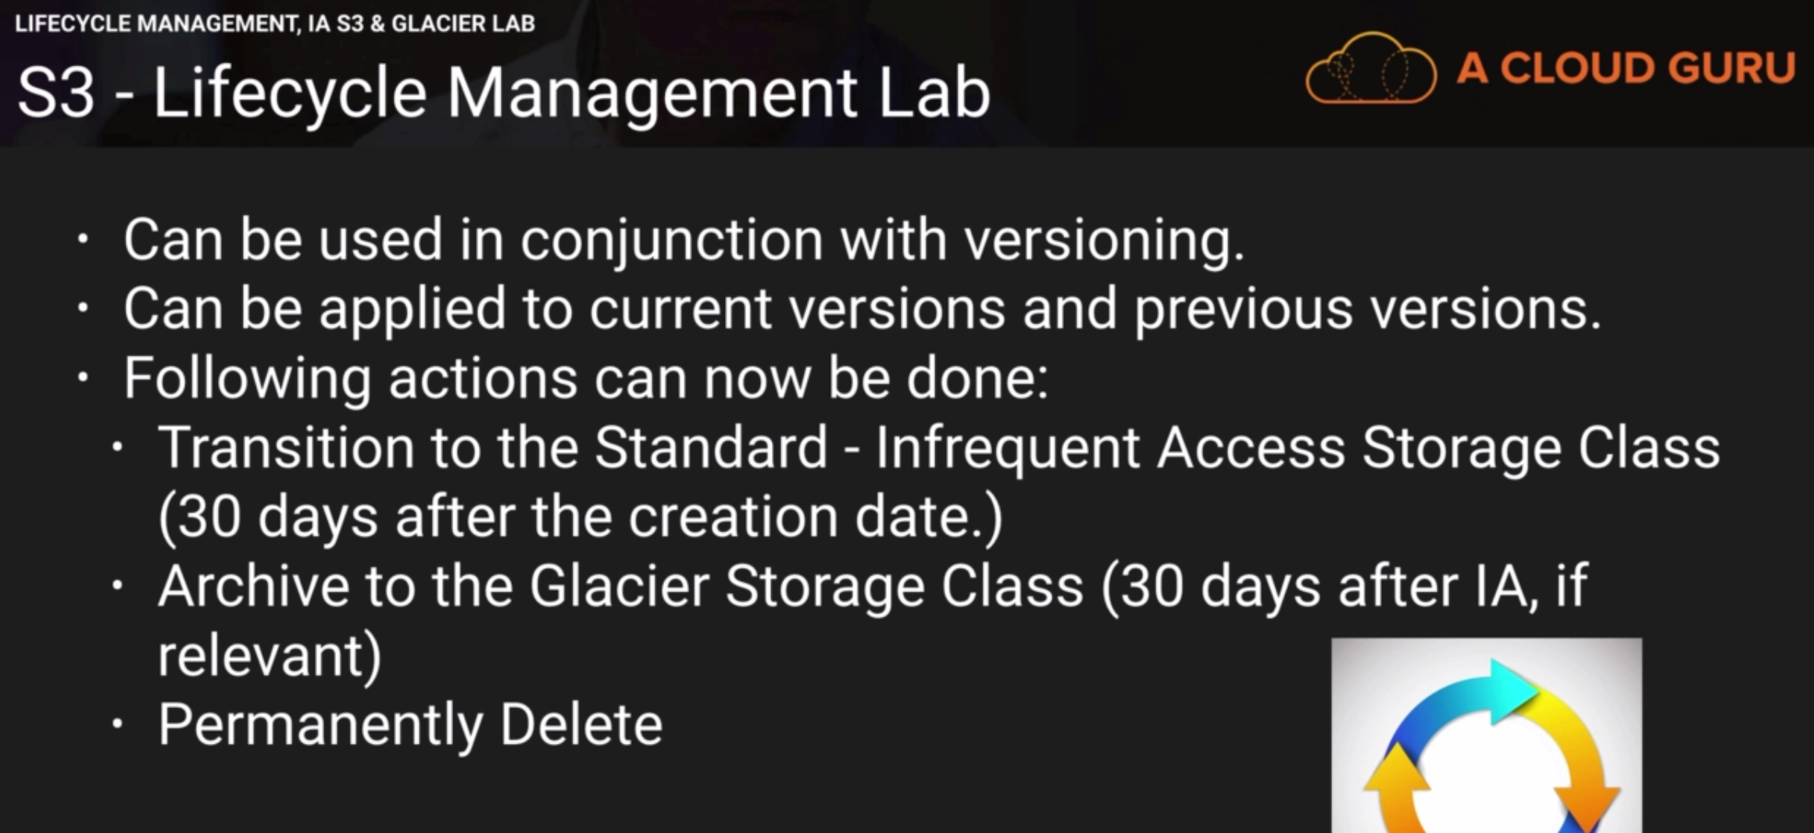

It can be done both with and without versioning.

IA minimum 30 days after and Glacier minimum 60 days after. We can also configure expiration here.

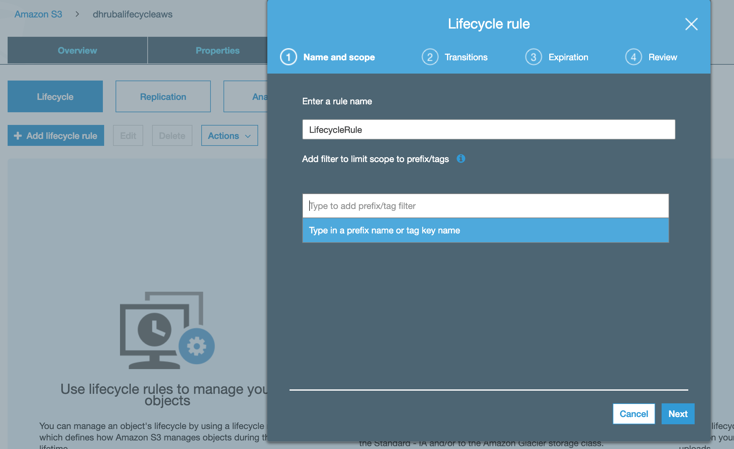

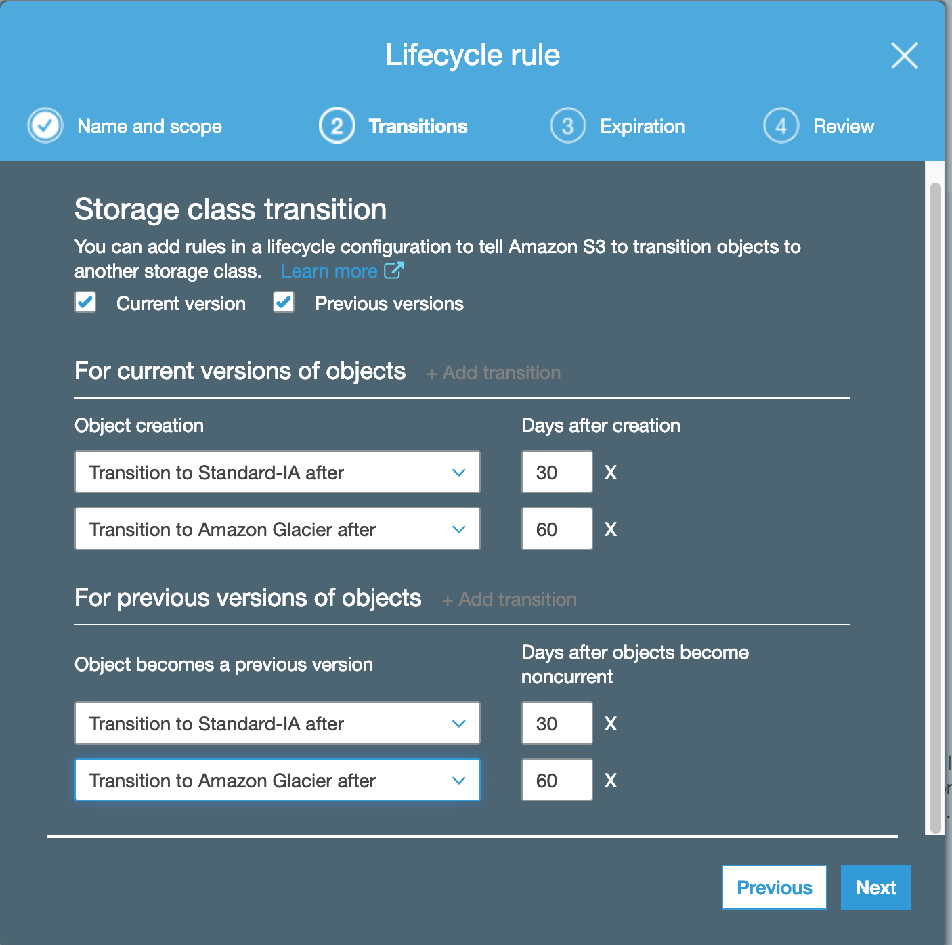

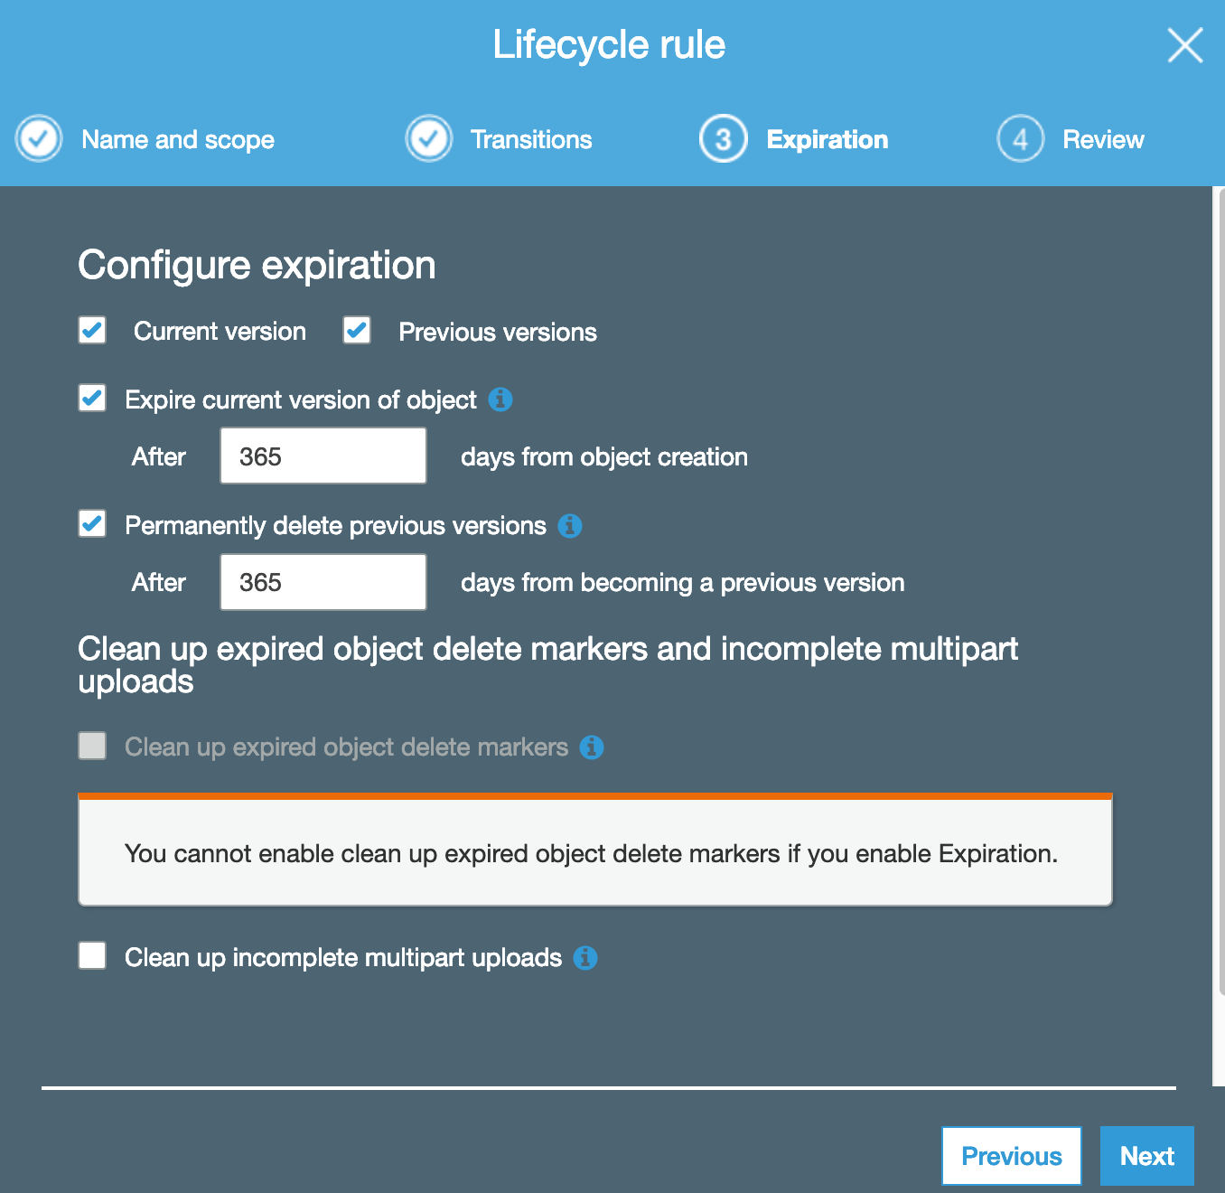

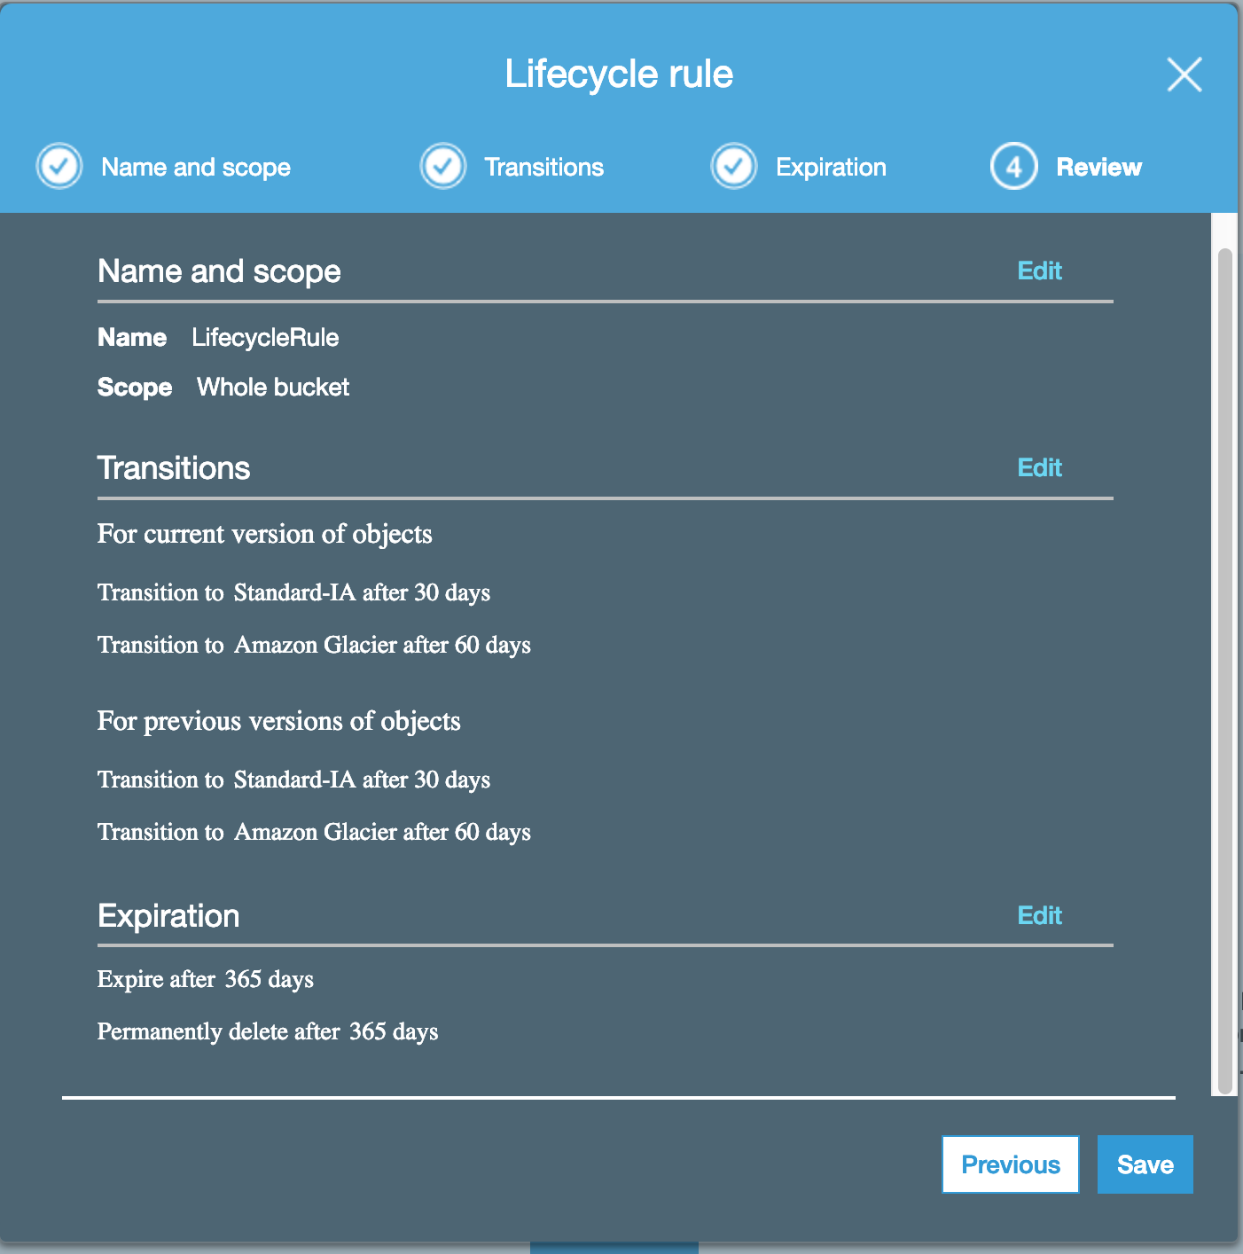

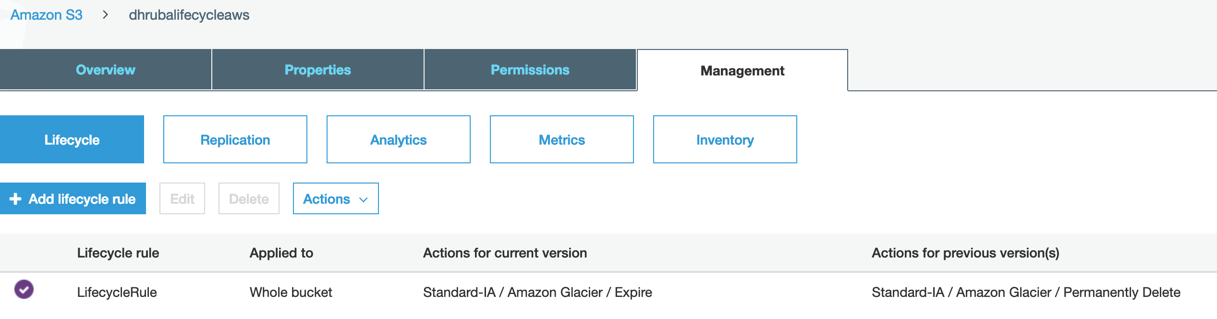

**CloudFront:**

A content delivery network (CDN) is a system of distributed servers (network) that deliver webpages and other web content to a user based on the geographic locations of the user, the origin of the webpage and a content delivery server.

**Different latency without CDN:**

All users are trying to hit a single location resulting in different latency.

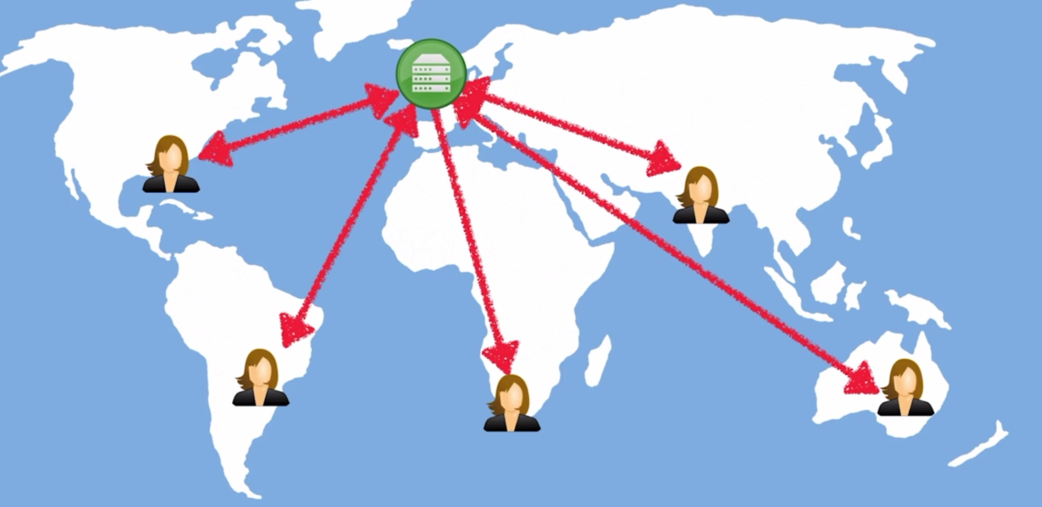

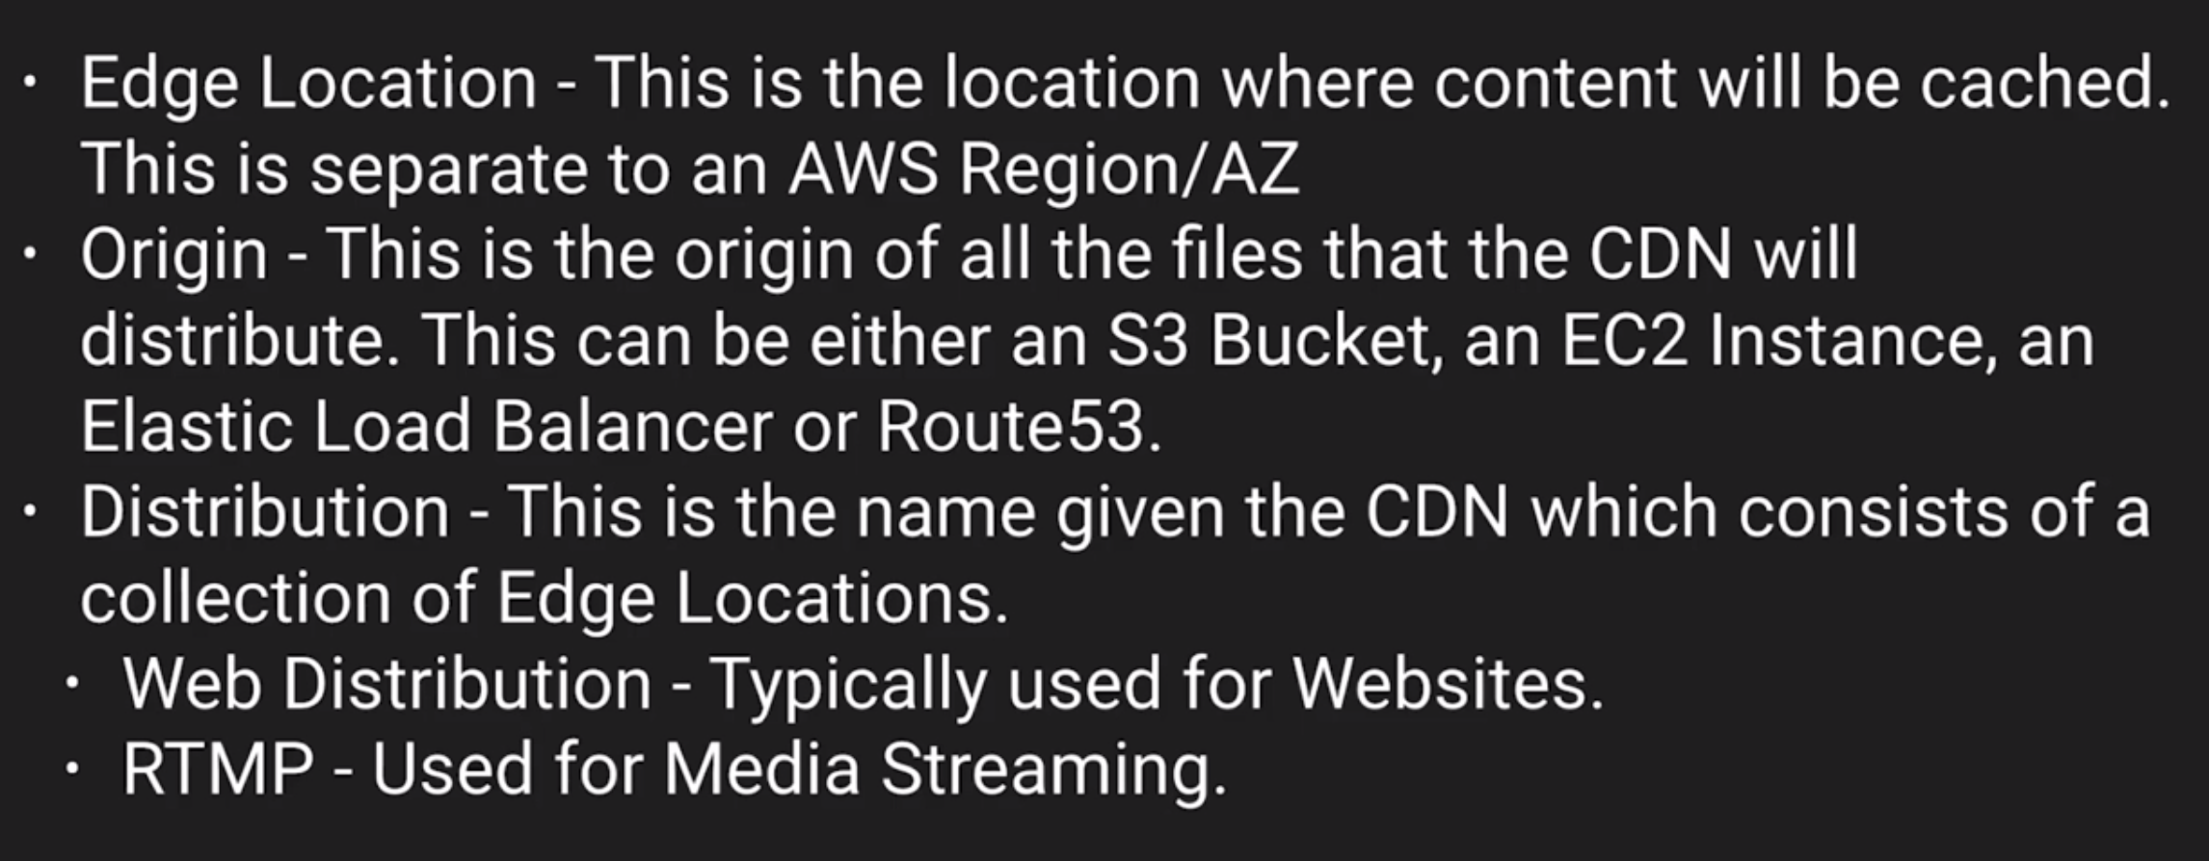

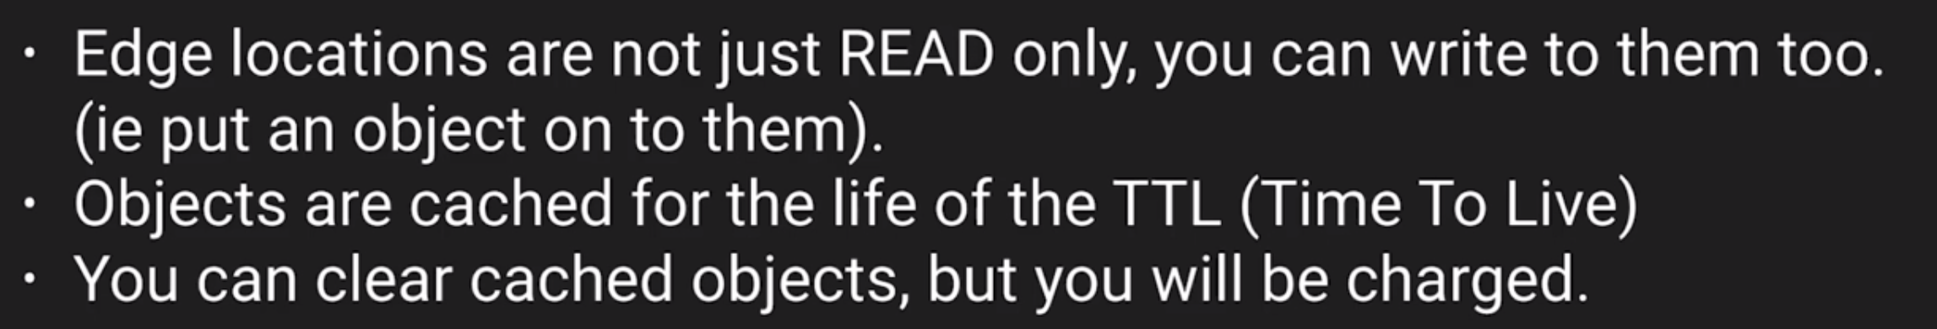

**CDN:**

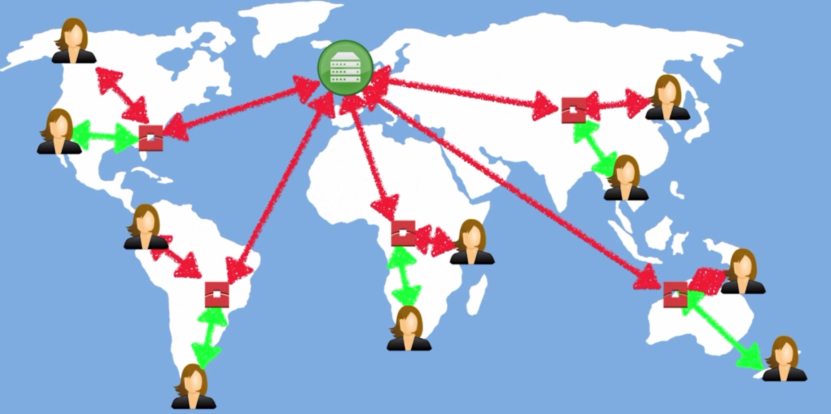

Here the request first goes to cache (edge location) and if not found, it is routed to origin. Once it is downloaded from origin, the next user can get it from edge location. Thus, only the first user suffers. An object lives for its defined TTL. If we delete before TTL, there is a charge for that.

Amazon *CloudFront can be used to deliver your entire* website or application, including dynamic, static, streaming, and interactive content using a global network of edge locations. Requests for your content are automatically routed to the nearest edge location, so content is delivered with the best possible performance.

It is optimized to work with other Amazon web services like S3, EC2, Elastic Load Balancing and Route 53. It also works seamlessly with any non – aws origin server, which stores original, definitive versions of your files.

**Creating a cloudfront Distribution:**

We can create 2 types of distribution: web and rtmp(flash)

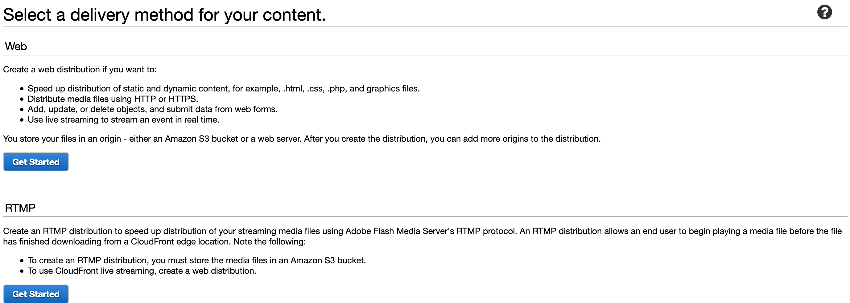

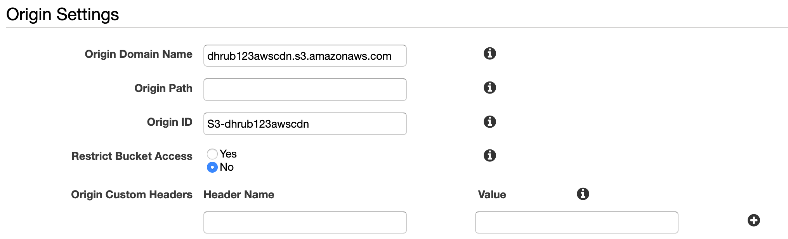

The origin is the aws bucket name. It can be an ec2 or elb or route 53 etc.

The origin path can be a folder in the bucket. If we restrict bucket access, the s3 bucket can only be accessed through cloudfront.

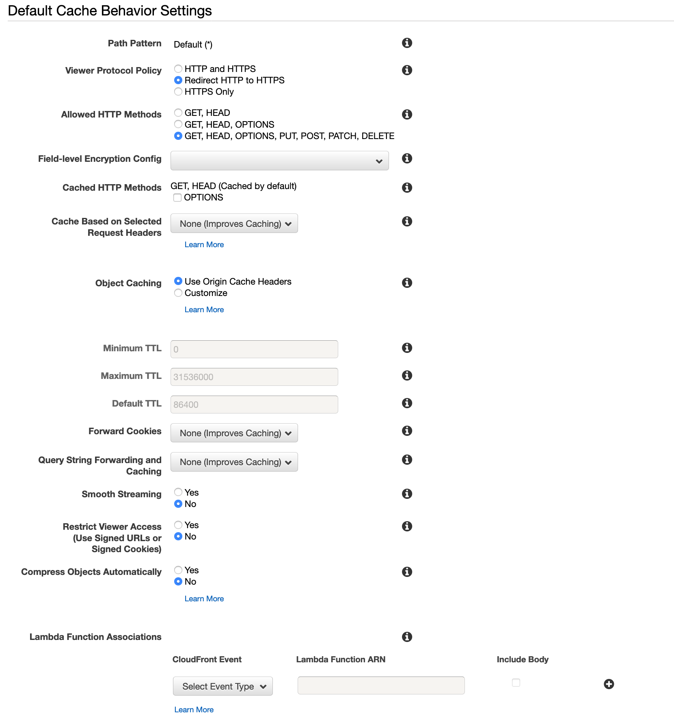

The path pattern is a regular expression. It can be configured to lookup only pdfs or jpegs for example. If put is allowed, users will be able to upload in CDN. TTL is the time to live in seconds. Default is 86400 seconds which is 24 hours. In case of private content, we will need to restrict viewer access using signed URLS.

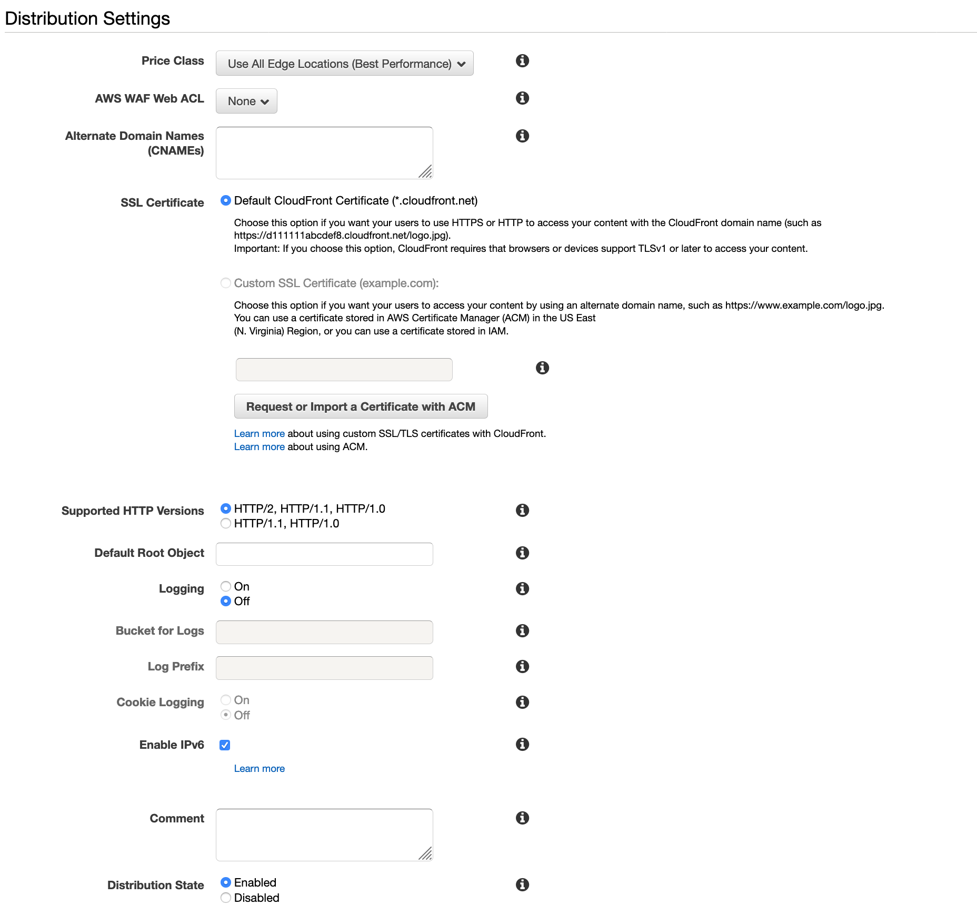



Alternate domains when specified allow us to specify a cname instead of the autogenerated domain name which users can use to access content. But this will also require a custom SSL certificate.

Distribution Settings:

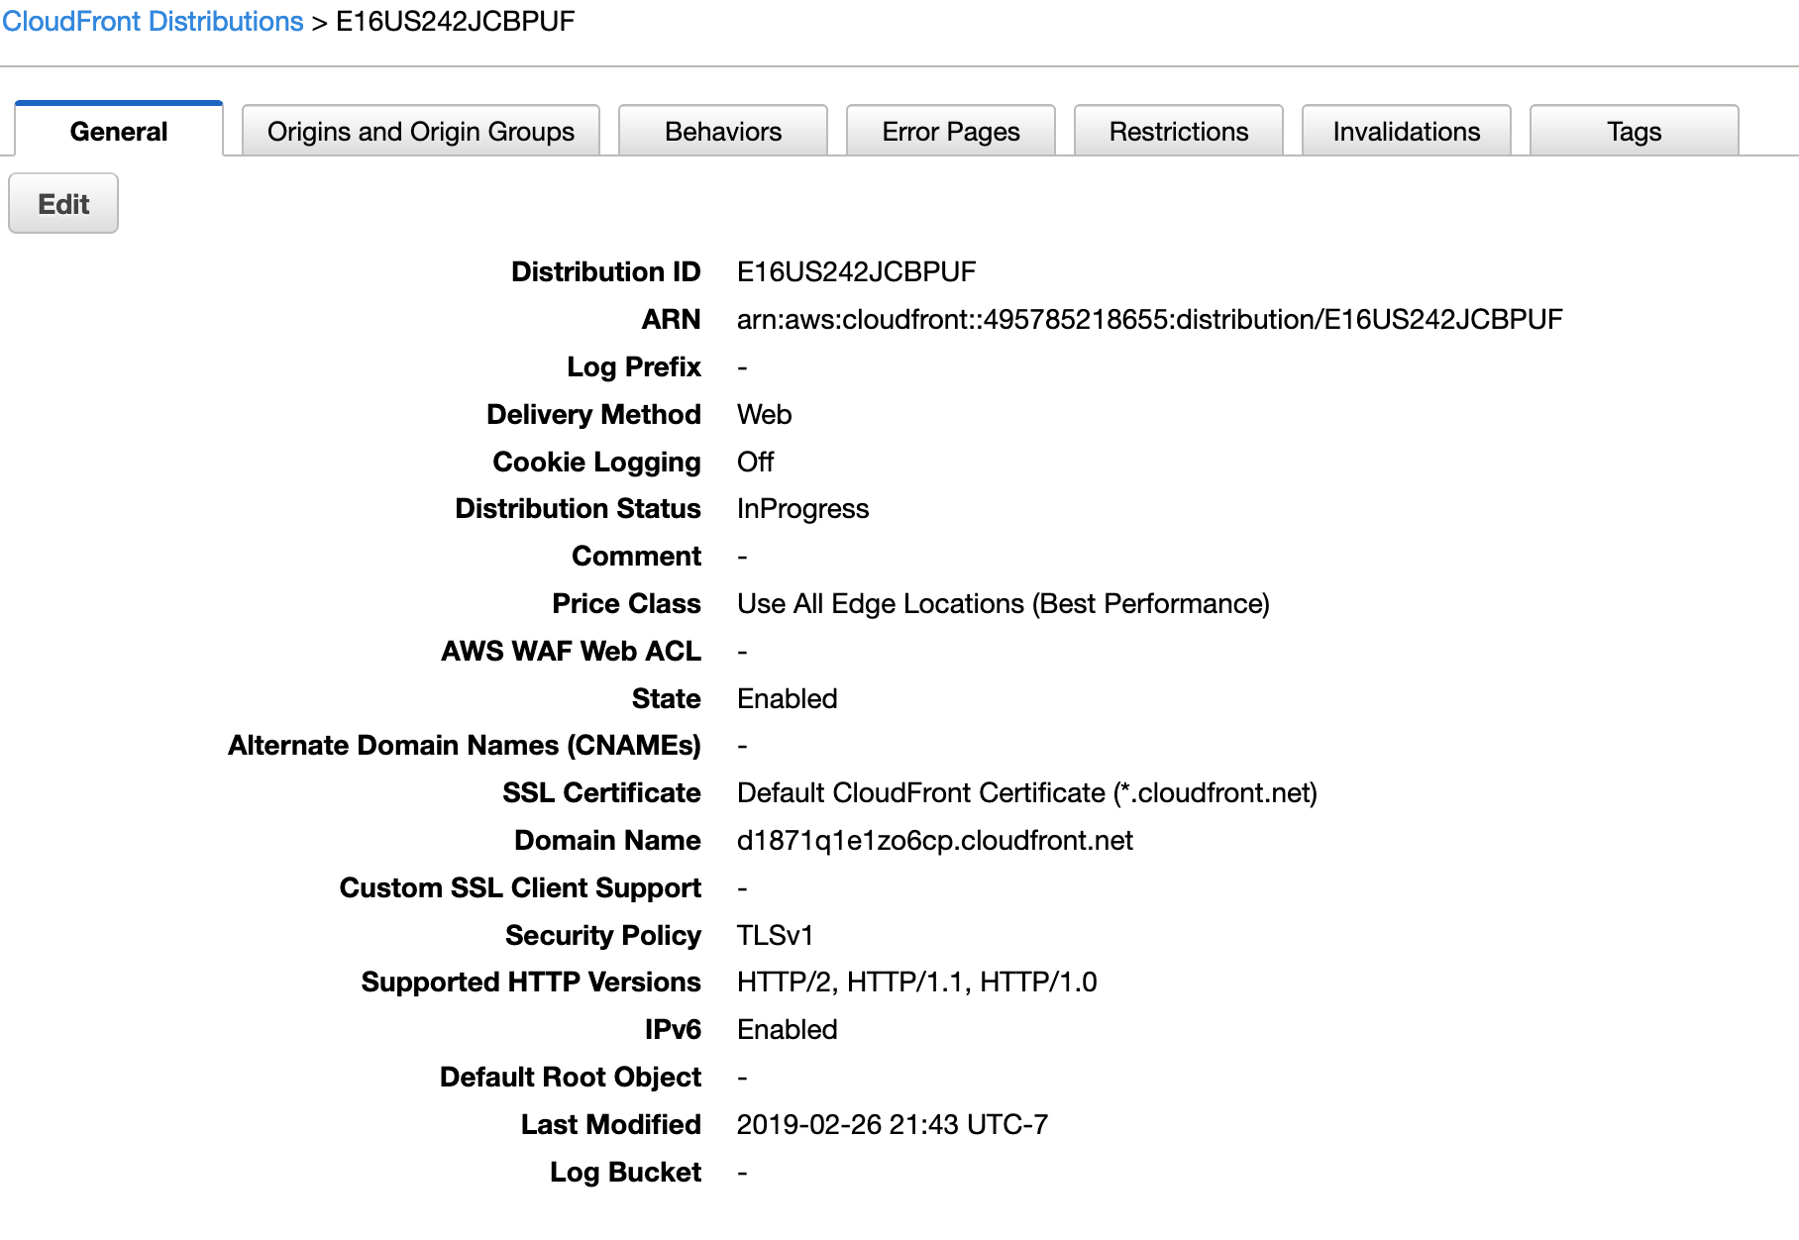

There can be multiple specified origins for a distribution.

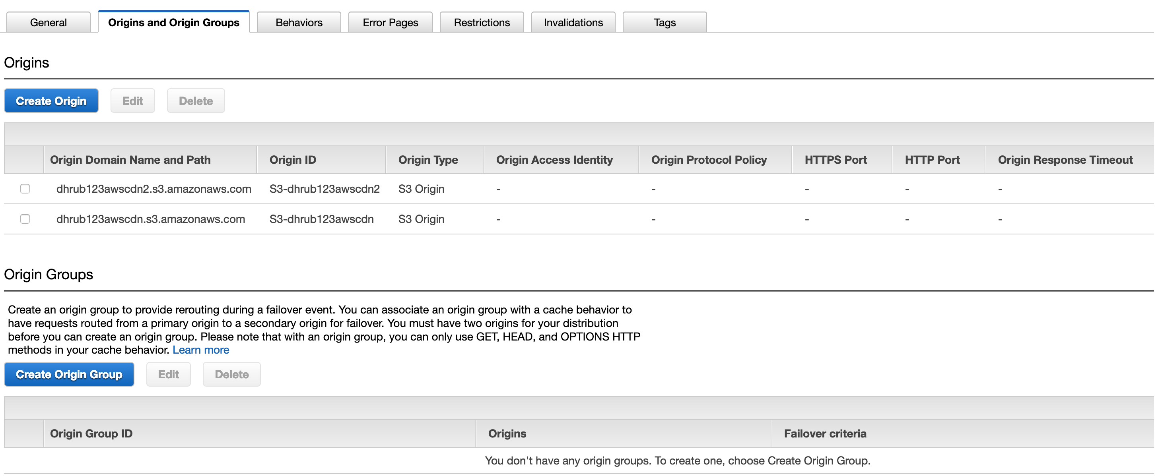

Under behavior, we can define new behavior e.g.: lookup pdfs and jpegs.

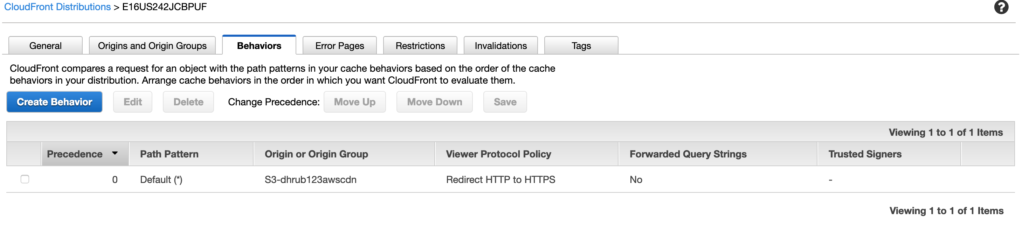

Under errors, an error page can be defined.

Under restrictions, we can add geo restriction for a content by creating either a blacklist of countries or whitelist of countries but not both.

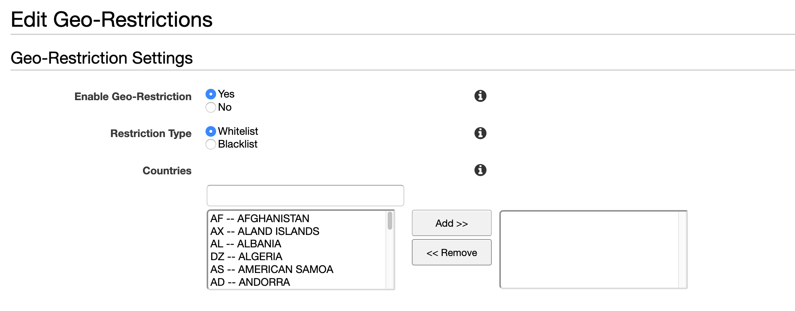

Under Invalidations, we can invalidate and delete an object without having to wait for ttl of that object but that comes with a charge.

**S3 – security and encryption:**

**Security:**

By default, all newly created buckets are PRIVATE.

Access Control to buckets can be implemented using

* Bucket Policies - applicable bucket wide
* Access Control Lists - used to apply security to individual files

S3 buckets can be configured to create access logs which log all requests to S3 bucket. This can be done to another bucket.

**Encryption:**

* Data in Transit:
  + SSL/TLS
* Data at Rest:
  + Server-side encryption:
    - S3 Managed Keys – SSE-S3(Amazon managed)
    - AWS Key Management Service, Managed Keys – SSE-KMS (Amazon managed)
    - Server-side encryption with customer provided keys – SSE-C (Amazon is responsible for encryption and decryption using the key)
  + Client-Side Encryption (when customer encrypts and then uploads data to AWS)